PRT631 INFORMATION SYSTEMS PRACTICE
FINAL REPORT
TrailAsia
Travel Operations and Traveller Safety Platform
A digital service for Himalayas Travel and Tour, Sydney
Student | Student ID
Kishor Aryal | s394008
Bibek Kumar Chaudhary | s395751
Vishal Rawat | s394591
Pratik Thapa Magar | s395120

Unit | PRT631 Information Systems Practice
Submitted to | Jamal EL-Den
Campus | Sydney, Charles Darwin University
Date | October 2026

Himalayas Travel and Tour is a hypothetical organisation created for this assignment. Market, regulatory and traveller-risk information is drawn from published sources; organisational details and all financial values are planning assumptions.
Contents
Executive summary 4
Project definition 5
Background 5
Approach 5
Project objective 5
Project outcome 5
Project scope 5
Assumptions 6
Organisation chart 6
Project approach 8
Project management methodology 8
Resourcing planning 8
Business case 9
Project plan and schedule 9
Milestones 9
Estimated costs 9
Cost-Benefit Analysis 10
Risks assessment and mitigation plan 10
Risk matrix 11
Requirements 12
Business requirements 12
Functional requirements 12
Non-Functional requirements 13
Technical requirements 14
Report requirements 14
User stories 14
Operational Requirements (Optional) 15
Regulatory and Compliance Requirements (Optional) 15
User Requirements (Optional) 15
Data Requirements (Optional) 16
Process Requirements (Optional) 16
Environmental Requirements (Optional) 16
System analysis and design 17
User case diagram and description 17
Activity diagram and description 18
Domain model class diagram and description (Optional) 21
Sequence diagram and description (Optional) 21
Enterprise architecture 24
Data flow diagram level 0 24
Data flow diagram level 1 24
ERD and description 26
Data dictionary 28
UXUI 32
Site map 32
Wireframe 33
User flow diagram 34
User journey scenario (optional) 35
Prototype 37
Main components and functionalities 37
Link of the prototype 37
Development 38
Requirement matrix 38
Benefit realisation 38
Jira project set up (Optional) 39
Confluence set up (Optional) 39
Testing 40
Test Plan 40
Test cases 41
System implementation 43
System Implementation Planning 43
Security, disaster and contingency planning 45
Security 45
Disaster Recovery Planning 45
Contingency Planning 46
Limitation and future work 47
Limitation 47
Future work 47
Conclusion 48
References 49

Executive summary
Himalayas Travel and Tour is a Sydney trekking agency with about 25 staff. It sells trips in Nepal, Bhutan and Tibet and is expanding across Asia. Its bookings, traveller documents, ground-operator confirmations and payments live in spreadsheets, email and WhatsApp. Nobody can see a booking's true state without asking the consultant who owns it, and once a group leaves Australia the agency cannot see them at all.
Our Assignment 1 business case compared four options (carry on, improve the spreadsheets, buy an off-the-shelf tour-operator product, build a tailored platform) and recommended the tailored build. It scored 4.25 out of 5, against 3.55 for the best bought product. The build is justified mainly by the traveller-safety features, which cannot be bought. This report documents the platform we then built, TrailAsia.
TrailAsia is a working prototype with four connected parts:
- A staff portal for bookings and itineraries, traveller records and documents, ground operators, multi-currency payments, tasks and handovers, a safety desk and reports.
- A traveller portal (phone-first) where a traveller sees their trip, uploads documents, shares location with consent and raises a two-tap SOS.
- An operator portal where ground operators confirm or decline requests.
- TrailAsia Book, a public website for browsing destinations and sending an enquiry, which also gives travellers a second route into their account.
The system has 23 database tables, 156 API endpoints, four staff roles and 21 notification types. 472 automated tests across 21 suites pass. Key rules are enforced on the server: an SOS can never be refused, location is recorded only with per-trip consent and deleted 30 days after the trip, the person who records a document cannot verify it, and the consultant who sold a trip cannot record that it was paid.
Some items in the business case are not built: the after-hours chatbot, the fair-price guide and scam alerts, online card payment through a gateway, multi-factor authentication, offline operation and a native mobile app. The four scheduled jobs (payment reminders, task reminders, SOS escalation and location purge) are written and tested but not yet connected to a scheduler. Nothing is deployed, and the system has not been load-tested. The Limitation and future work section sets these out and proposes next steps.

Project definition

Background
Himalayas Travel and Tour is an organisation created for this assignment. Its market and risk context is drawn from published sources, while organisational details and financial values are planning assumptions. Australian travel to Asia is growing: the Australian Bureau of Statistics reports that 57% of short-term residents returning in April 2026 came back from Asia, up from 53% a year earlier (ABS, 2026). The Department of Foreign Affairs and Trade handled more than 26,000 consular cases in 2024–25, and nearly one in three occurred in Southeast Asia (DFAT, 2025). For a trekking agency the specific risk is documented: Smartraveller reports that Nepal prosecuted 32 people in April 2026 over helicopter-rescue insurance fraud (Smartraveller, 2026).
A trekking booking is closer to a project than a reservation. It chains accommodation, guides, permits, transfers and equipment across several countries, each with its own document requirements, and high-altitude trips need insurance with stated altitude cover. Today this is held together by one consultant per booking.

Approach
The business case recommended a tailored build with a development partner, delivered iteratively and in stages. For the prototype, the team built a React and Node.js application in small phases. Each phase added one slice of the system (for example traveller sign-in and safety, tasks and handovers, in-app notifications, payment reminders, the public site, document upload, operator documents, SOS assignment and escalation, email delivery and the SOS log) and was recorded in a phase document in the project workspace. Every phase added automated tests, and the final suite has 472.

Project objective
The project has two linked objectives, taken from the business case:
- Operational: bring bookings, itineraries, traveller documents, operator confirmations and payments into one tool, replacing four disconnected ones.
- Customer-facing: give travellers a way to protect themselves overseas (consented location sharing, one-tap SOS, insurance and altitude details on file), so that safety becomes the reason a customer chooses the agency.

Project outcome
The outcome is a working multi-portal prototype. It runs locally against MySQL, with API documentation, migrations, seed data and an automated test suite. It demonstrates the full path from a public enquiry to a confirmed booking, document checking, operator confirmation, payment tracking and a traveller raising and staff resolving an SOS. It is a prototype, not a production service: nothing is hosted, and the business-case benefits have not been measured in use (see Benefit realisation).

Project scope
In scope (built) | In the business case but not built
Authentication for staff, travellers and operators; staff accounts and four roles | After-hours chatbot with safety escalation
Destinations and per-destination document requirements | Fair-price guide and scam alerts
Travellers, documents with file upload, verification, per-trip checklist | Online card payment through a PCI DSS gateway (payments are a manual ledger)
Bookings, party, multi-country itinerary, status lifecycle, readiness | Multi-factor authentication
Ground operators: vetting, confirmations, operator portal | Encryption at rest, independent penetration test
Instalment plans and multi-currency ledger with reminders | Offline-tolerant mobile app (the traveller app is a web portal)
Tasks, generated tasks and handovers | Scheduler running the four jobs automatically
Location consent, position sharing, SOS, assignment, escalation, SOS log | SMS or phone alerts for SOS (only bell and email today)
In-app notifications and email through Mailgun with a delivery log | Report export to file
Commercial and operational reports; public site and enquiry form | Hosting, domain and HTTPS
Table 1: Scope of the prototype against the business case
The business case also excluded some items from release 1: a public self-service booking portal (we built an enquiry form only, not self-service booking), changing the agency's existing finance software, automated supplier contracting and price negotiation, satellite or beacon integration, and demand forecasting. These remain out of scope.

Assumptions
- The agency has about 25 staff and no in-house IT department, and serves eight or more Asian destinations.
- Routine bookings can follow a standard process, while complex or risky trips stay with a coordinator.
- Enough travellers will opt in to location sharing for the safety features to matter. This is the key assumption in the business case.
- A payment gateway can be integrated later; until then payments are recorded manually.
- Travellers have a smartphone browser. The app is not a replacement for a personal locator beacon in remote areas.
- All financial values are planning assumptions that need validating before any funding decision.

Organisation chart
The chart shows the governance proposed in the business case (a steering committee meeting fortnightly) and the agency teams the platform serves. The delivery team is the four students named on the cover.
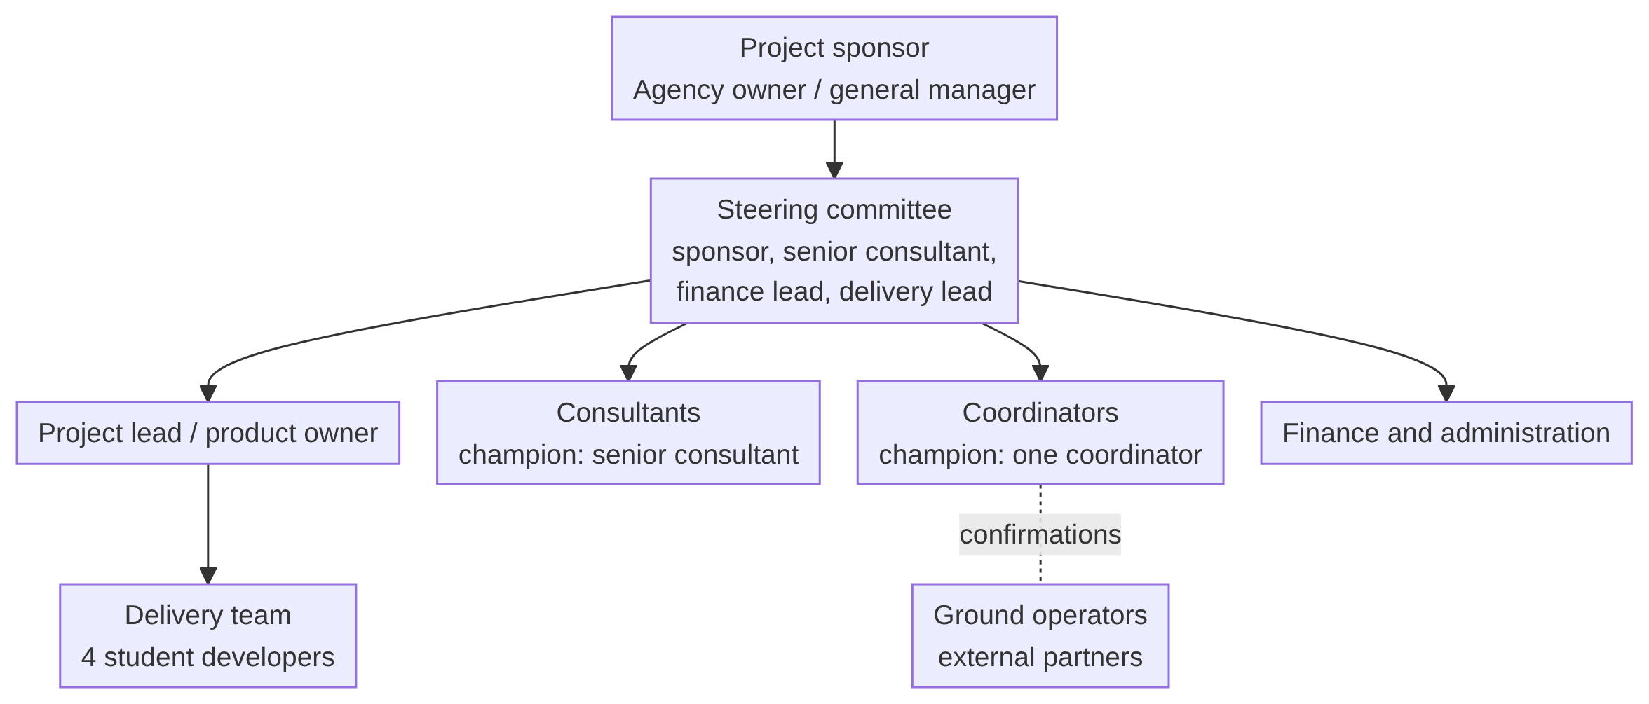
Figure 1: Project governance and agency teams
TO COMPLETE: add each team member's project role (for example project lead, back-end, front-end, testing and documentation) and the date ranges they worked on, if your brief asks for individual contribution.

Project approach

Project management methodology
The business case chose an iterative approach (Valacich et al., 2012), because the agency has never commissioned a system and its early requirements were expected to contain mistakes. Building and testing in small parts lets those mistakes surface while they are cheap to fix. Each stage ends with a go or no-go gate. Two gates matter most: the build may not start until discovery confirms the financial assumptions, and the pilot may not start until the chatbot's safety escalation has been tested with deliberately created safety scenarios.
In the prototype the iteration took the form of one phase per capability, each with its own written record and tests (see Approach above). Work was tracked in the project workspace and the Git repositories.

Resourcing planning
Resource | Role in the project | Source
Project sponsor (agency owner or general manager) | Approves milestones, scope and assumption changes | Business case 9
Senior consultant (champion) | Represents daily operations; answers colleagues' questions at rollout | Business case 6.2, 9
Coordinator (champion) | Operator confirmations and departures | Business case 6.2
Finance lead | Reconciliation requirements; audit trail | Business case 9
Delivery team | Four students: design, build, test, document | Cover page
Development tools | Node.js 20, MySQL 8, React 18, Git; Mailgun for email | Technology stack
Estimated external cost | Planning budget of AUD 96,000 in year one (assumes a development partner) | Business case 7.1
Table 2: Resources
TO COMPLETE: add the team's own hours or effort if you recorded them, and which team member owned which module.

Business case
This section summarises the Assignment 1 business case. Its figures are planning assumptions from that submission. They have not been updated with measured results.

Project plan and schedule
Stage | Main work | Weeks
1. Discovery | Study consultants at work, measure current booking activity, document requirements by destination, test assumptions | 3
2. Define | Agree requirements, business rules, acceptance criteria, privacy approach for location data, integration scope | 3
3. Prototype | Core screens for booking, itinerary and traveller app; test with consultants and a small traveller group | 3
4. Build | Booking, CRM, coordination, payments, reporting and safety modules | 5
5. Integrate | Payment gateway, messaging channels, after-hours chatbot | 2
6. Test | Functional, security, privacy and recovery testing; explicit chatbot escalation testing | 2
7. Pilot | One destination programme end to end; train staff; offer the app to departing travellers | 1
8. Roll out | Remaining destinations; migrate legacy spreadsheets; early support | 1
Total |  | 20
Table 3: Proposed 20-week delivery schedule (business case, Table 3)

Milestones
Gate | Decision it supports
End of Discovery | Do the measured baselines and traveller interest support the financial case? If not, reconsider and buy an existing product
End of Define | Requirements, business rules and the privacy approach for location data are agreed
End of Prototype | Consultants and a small traveller group have tested the core screens
End of Build | Staff modules and safety module are complete and tested
Before Pilot | Chatbot safety escalation tested with deliberately created safety scenarios (go or no-go)
End of Pilot | One destination has completed a booking-to-departure cycle without data loss; legacy spreadsheets can be retired
Table 4: Stage gates
TO COMPLETE: add the actual milestone dates for this unit (for example the weekly submissions) alongside the proposed gates, if your brief asks for a schedule of what really happened.

Estimated costs
Budget item | Estimated AUD
Discovery and requirements | 9,000
User experience and interface design | 11,000
Core platform development (staff modules) | 32,000
Traveller app and safety module development | 18,000
Integration: payment gateway, messaging, chatbot | 12,000
Testing, security and privacy review | 8,000
Training and change support | 4,000
First-year hosting and support | 7,000
Contingency | 5,000
Estimated first-year total | 96,000
Table 5: Planning budget (business case 7.1)

Cost-Benefit Analysis
The base case assumes the platform saves about 1,400 hours a year of consultant and coordinator time (less itinerary rebuilding, confirmation chasing and reconciliation) at a burdened rate of AUD 48 an hour, which is AUD 67,200. Another AUD 8,000 a year comes from avoided rework, document errors and reconciliation losses. The annual benefit is therefore AUD 75,200. Nobody is made redundant: the value is capacity to handle more bookings with the same staff.
Item | Year 0 | Year 1 | Year 2 | Year 3
Initial project cost | -96,000
Estimated gross benefit |  | 75,200 | 75,200 | 75,200
Ongoing support after year one |  |  | -16,800 | -16,800
Net cash flow | -96,000 | 75,200 | 58,400 | 58,400
Table 6: Cash flow in AUD (business case 7.2)
Measure | Base case | Low case (900 h, $5,000 other)
Gross annual benefit | AUD 75,200 | AUD 48,200
Net benefit over three years | AUD 96,000 | about AUD 15,000
Nominal ROI | about 100% | about 16%
NPV at 5% | about AUD 79,000 | positive but thin
Payback after go-live | about 17 months | beyond 30 months
Table 7: Financial summary
The figures depend almost entirely on an assumed time saving that nobody has measured. Two further benefits were left out because they cannot be quantified in advance: extra bookings won through the safety features, and losses avoided by preventing a fraudulent evacuation claim or a data incident. We re-computed the base-case NPV and net benefit from the cash-flow table and they agree with the business case.

Risks assessment and mitigation plan
ID | Risk | Level | Mitigation (business case 8.1) | Status in the prototype
R1 | Breach exposing passport, health or location data | High | Encryption in transit and at rest, MFA, least privilege, audit logging, independent penetration test, breach response plan | Roles, hashing, masking, audit trails, rate limits done. MFA, encryption at rest, penetration test not done
R2 | Location data misused or over-retained | High | Opt-in, purpose limitation, automatic deletion at trip end, privacy impact assessment | Per-trip consent, tap-to-send only, 30-day deletion job written. Job not yet scheduled
R3 | Low traveller adoption | High | Prototype testing with real travellers, pre-departure onboarding | No user testing with travellers yet
R4 | Connectivity failure on treks | High | Offline-tolerant sync, cached data, state the app does not replace a beacon | Not built; nothing works offline
R5 | Chatbot mishandles a safety message | High | Conservative escalation, adversarial testing, on-call rota | Chatbot not built, so the risk is deferred
R6 | Delivery partner dependency | Medium | Source code ownership, escrow, documented configuration | We own the code and have written documentation
R7 | Fair-price data becomes stale | Medium | Scheduled review, visible dates, ranges | Feature not built
R8 | Cost or scope overrun | Medium | Stage gates, fixed-price stages, contingency | Scope was cut to fit (see Scope)
R9 | Staff resistance to the new workflow | Medium | Co-design, champions, parallel running | Not yet tested with staff
Table 8: Principal risks and their status

Risk matrix
The matrix places each risk by the team's own judgement of likelihood and impact. These ratings are our assessment, not measured values.
 | Low impact | Medium impact | High impact
High likelihood | R4
Medium likelihood | R7 | R6, R8, R9 | R1, R3
Low likelihood |  |  | R2, R5
Table 9: Risk matrix (likelihood against impact), risk IDs as in the register above

Requirements
Requirements below were derived from the business case and from the behaviour enforced in the system. Each has an ID so the requirement matrix (Development section) can trace it to a module and a test suite.

Business requirements
ID | Requirement | Business case reference
BR-1 | Hold bookings, itineraries, traveller records, operator confirmations and payments in one system instead of four tools | 1.3
BR-2 | Let a consultant build a multi-country itinerary once instead of rebuilding it per enquiry | 1.3
BR-3 | Track traveller documents against each destination's actual requirements and show gaps before departure | 1.3, 5.3
BR-4 | Record ground-operator confirmations against the booking they belong to | 1.3
BR-5 | Track multi-currency deposits and instalments against bookings | 1.3
BR-6 | Give travellers a way to reach the agency and be located in an emergency, with consent | 1.3, 4.3
BR-7 | Give management pipeline and demand visibility without asking consultants individually | 1.3
BR-8 | Protect passport, health and location data under the Privacy Act 1988 (APP 11) | 8.2
BR-9 | Keep separation of duties between sales, document verification and finance | 8.2
BR-10 | Let the agency verify insurance, including altitude cover, before agreeing to an emergency evacuation | 4.3
Table 10: Business requirements

Functional requirements
ID | Module | The system shall | Status
FR-1 | Authentication | Sign in staff, travellers and operators separately; issue 15-minute access tokens and rotating 7-day refresh tokens; lock an account for 15 minutes after 5 failed attempts | Built
FR-2 | Staff accounts | Let an administrator create, edit, deactivate, unlock and reset staff accounts with four roles; refuse to remove the last active admin | Built
FR-3 | Destinations | Maintain destinations and the documents each requires (type, lead time, minimum passport validity, altitude cover) | Built
FR-4 | Travellers | Maintain traveller profiles, passport, emergency contact, dietary and medical notes; mask passport numbers for finance and in lists | Built
FR-5 | Documents | Record documents with optional file upload (PDF, PNG, JPEG, up to 10 MB); let only a coordinator or admin verify or reject; refuse to verify an expired document | Built
FR-6 | Checklist and readiness | Compute each traveller's checklist per trip (missing, on file, submitted, verified, rejected, expired), including passport validity and altitude cover checks | Built
FR-7 | Bookings | Create bookings with references TA-YYYY-NNNN, a party, an ordered multi-country itinerary and a status lifecycle; cancel with a reason | Built
FR-8 | Operators | Maintain an operator directory with vetting; raise, request, answer and cancel confirmations; allow only active, vetted operators to be used | Built
FR-9 | Operator portal | Let an invited operator see its own requests and confirm or decline them (a decline needs a reason) | Built
FR-10 | Payments | Plan instalments; record payments in any currency with a stored exchange rate; settle as cleared, failed or refunded; compute paid, outstanding and overdue from the ledger | Built
FR-11 | Tasks | Create and assign tasks, keep a history of every change, generate tasks from document gaps, and hand over one person's open work to another | Built
FR-12 | Safety | Record location consent per trip and positions only with consent; accept an SOS at any time without consent or rate limit; let staff acknowledge, assign and resolve it; escalate unclaimed alerts every 5 minutes; keep an append-only SOS log | Built (escalation job not scheduled)
FR-13 | Notifications | Send in-app notifications to staff, travellers and operators, and email copies through Mailgun with a delivery log; a notification failure must never undo the action that caused it | Built
FR-14 | Reporting | Provide commercial and operational reports computed live; a consultant sees only their own performance row | Built (no export)
FR-15 | Public site | Show active destinations and testimonials; accept a booking enquiry (creating an enquiry-stage booking) and a contact message; rate-limit both forms | Built
FR-16 | Fair-price guide and scam alerts | Show local price ranges and location-based scam warnings | Not built
FR-17 | After-hours chatbot | Answer routine questions overnight and escalate every safety message to a human | Not built
FR-18 | Online payment | Let a traveller pay an instalment through a PCI DSS-compliant gateway | Not built
Table 11: Functional requirements

Non-Functional requirements
ID | Area | Requirement | How it is met or the gap
NFR-1 | Security | Passwords hashed; sessions short-lived; roles enforced on every route | bcrypt cost 12, minimum 12 characters; JWT 15 min; role checks on the server
NFR-2 | Security | MFA for staff; encryption in transit and at rest | Not met: no MFA; HTTPS and encryption at rest depend on deployment, which has not happened
NFR-3 | Privacy | Location opt-in, purpose-limited, deleted after the trip | Met in code; deletion job needs a scheduler
NFR-4 | Reliability | Notifications, email and logging must not break a booking, payment or SOS | Each has a test
NFR-5 | Integrity | Multi-step changes must be atomic | Enquiry, activation, handover and session rotation run in database transactions
NFR-6 | Auditability | Financial figures and safety events must be traceable | Payment amounts cannot be edited; task history and SOS log are append-only
NFR-7 | Usability | Traveller portal usable on a phone; SOS cannot fire by accident | Large touch targets; two taps within 8 seconds
NFR-8 | Availability | RTO 4 hours, RPO 1 hour (safety module faster) | Targets only; no backup or failover implemented
NFR-9 | Connectivity | Safety functions work with poor network | Not met; nothing works offline
NFR-10 | Maintainability | Separate zones with low coupling | Routes, controllers, services and models are separate layers; business rules live in services
Table 12: Non-functional requirements

Technical requirements
Layer | Choice
Front end | React 18, Vite, React Router 6, plain CSS, JavaScript
Back end | Node.js 20, Express 4, REST under /api/v1, JSON
Database | MySQL 8 with Sequelize 6 and sequelize-cli migrations (SQLite in memory for tests)
Validation | Zod schemas on every request body and query
Authentication | JWT access token in memory plus rotating refresh token in an httpOnly cookie; only the SHA-256 hash is stored
Files | Multer, stored on local disk under random UUID names
Email | Mailgun HTTP API (optional; with no key configured, sends are logged and skipped)
Security middleware | Helmet, CORS limited to the client origin, express-rate-limit on sign-in and public forms
Testing | Jest and Supertest against the real Express app
Repositories | TrailAsia (server and client) and TrailAsia-Book (public client and small proxy server); one shared database
Table 13: Technical requirements

Report requirements
Report | Content | Who
Dashboard headline | Pipeline totals and departure summary for the next 30 days | Any staff
Commercial | Pipeline and conversion rate; won revenue by lead destination; consultant performance; cleared money in by month | Any staff (a consultant sees own row only)
Operational | Departure board (documents, operators, money ready or not); operator reliability; tasks raised against closed by month; overdue items across modules | Any staff
Payments and chase list | Per-booking balances, unpaid instalments, totals grouped by currency (never summed across currencies) | Any staff
SOS log | Every event on every alert, filterable | Any staff
Email log | Every email attempt and result | Admin
Table 14: Reports
Reports are computed from the operational tables when asked for. Nothing is stored for reporting, and there is no export to file.

User stories
ID | As a… | I want to… | So that… | Use case
US-1 | public visitor | browse destinations and send an enquiry | I can start planning a trek without calling | UC-01 to 03
US-2 | traveller | activate my account from an emailed link | I can see my trip | UC-10
US-3 | traveller | see which documents I still need and upload them from my phone | I am ready before departure | UC-13, 14
US-4 | traveller | turn location sharing on for one trip and off again | I stay in control of my data | UC-17
US-5 | traveller | press SOS twice to alert the agency, even without consent or signal quality | help starts quickly | UC-19
US-6 | consultant | build a multi-country itinerary and a party once | I do not rebuild a spreadsheet each time | UC-35 to 37
US-7 | consultant | see a booking's readiness (documents, operators, money) | I know what is outstanding without asking colleagues | UC-40
US-8 | coordinator | verify or reject a traveller's document with a reason | only checked documents count | UC-50
US-9 | coordinator | raise a confirmation only with a vetted operator and see which are unanswered | nothing relies on a WhatsApp reply | UC-41, 52, 53
US-10 | finance officer | record payments in the traveller's currency with the rate fixed at entry | reconciliation is accurate and auditable | UC-60, 61
US-11 | consultant | hand all my open tasks to a colleague with a reason | work continues when I am away | UC-46
US-12 | trip editor | see unclaimed SOS alerts, take or assign one, and close it with notes | every alert has an owner and a record | UC-47
US-13 | administrator | create and deactivate staff accounts | only current staff have access | UC-80
US-14 | ground operator | confirm or decline a request in a portal | I do not manage a separate inbox | UC-93
US-15 | manager | see the pipeline and demand by destination | I do not have to ask each consultant | UC-75
Table 15: User stories
TO COMPLETE: add acceptance criteria to each user story if your brief asks for them. The business rules in the data section of the reference document can be used as criteria.

Operational Requirements (Optional)
Operation depends on four jobs that must run on a timer: SOS escalation (every minute), payment reminders (daily), task reminders (daily) and location purge (daily). Staff must keep the safety desk open, which refreshes every 30 seconds. An administrator reads the email log to find failed sends. Operating hours cover the gap between a Sydney office closing at 5pm and trekking regions still active: the business case relies on the after-hours chatbot for this, and in its absence an on-call coordinator rota is needed.

Regulatory and Compliance Requirements (Optional)
The Privacy Act 1988 applies. Under Australian Privacy Principle 11 the agency must take reasonable steps to protect personal information and delete it when no longer needed. Health information (the medical notes on a traveller) is sensitive information. The Notifiable Data Breaches scheme requires a response plan. Card data must stay with a PCI DSS-compliant gateway, which is why the platform stores no card numbers. The ASD Essential Eight (multi-factor authentication, patching, backups) gives a baseline for a small agency without security staff.

User Requirements (Optional)
Travellers need clear plain-language statuses ("Being checked", "Not accepted" with a reason) and a phone-first layout. Consultants need flexibility rather than rigid forms. Coordinators need reliable partner confirmations and a view of departures in progress. Finance needs an audit trail and exact multi-currency reconciliation. Operators need a confirmation step that adds no administrative burden (business case 5.2).

Data Requirements (Optional)
Data is held in 23 MySQL tables (see the data dictionary). Passport and health data are the most sensitive. Location positions are kept for 30 days after the return date of the trip and then deleted, and the SOS log records that a position was sent but never the coordinates. Alerts themselves are kept indefinitely. Read notifications are deleted after 60 days and sessions that expired over 30 days ago are purged.

Process Requirements (Optional)
The core processes are: enquiry to confirmed booking, portal invitation and activation, document upload and verification, operator confirmation, payment, document-gap tasks and handover, location sharing, and SOS. Each is drawn as an activity diagram or described in the System analysis and design section.

Environmental Requirements (Optional)
Development runs on one machine: API on port 4000, staff client on 5173, TrailAsia Book on 5174, MySQL locally. Node.js 20 is required (see .nvmrc). No production environment, domain or HTTPS configuration has been chosen.

System analysis and design

User case diagram and description
The system has nine actors: the public visitor, the traveller, four staff roles (consultant, coordinator, finance officer, administrator), the ground operator, Mailgun (an external email service) and a scheduler (time). The four staff roles are shown as one generalised actor, "Agency staff", with the role restrictions written in the use case names. The diagrams are split in two to stay readable.
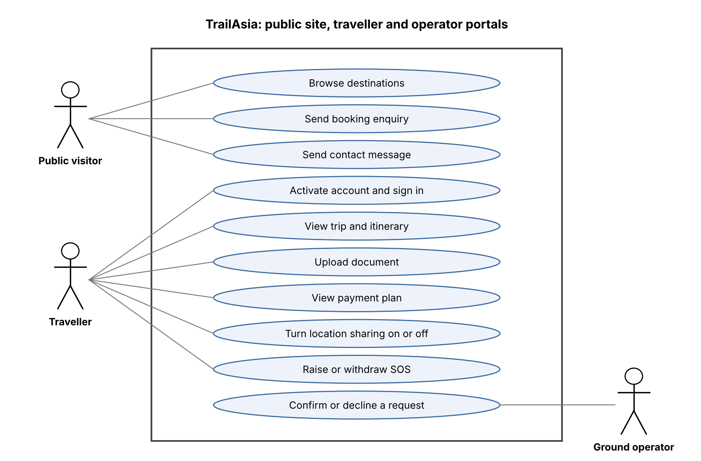
Figure 2: Use cases for the public site, traveller portal and operator portal
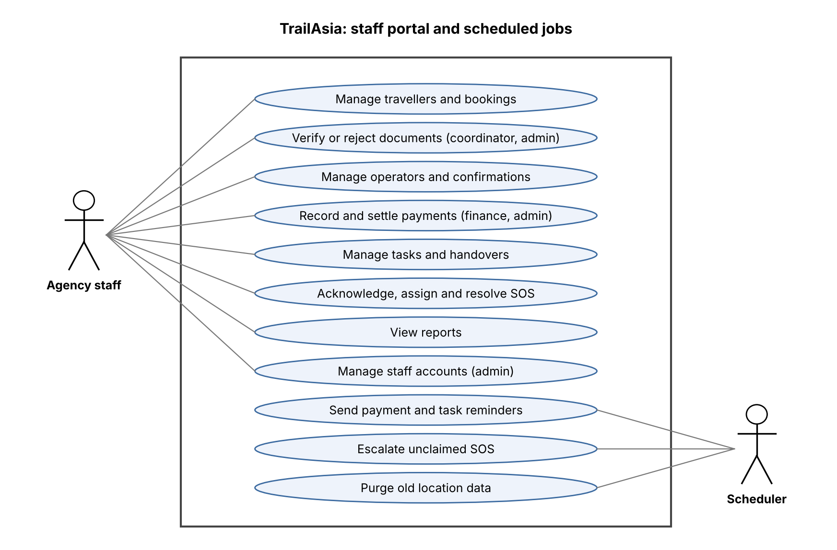
Figure 3: Use cases for the staff portal and scheduled jobs
Use case | Actor | Description and key rules
Send a booking enquiry (UC-03) | Public visitor | Submit name, email, destination (up to four more), dates, party size and message. The system matches or creates a traveller by email, picks an intake consultant and creates an enquiry-stage booking with one itinerary leg per destination. Rate-limited to 10 per 15 minutes per address
Upload a document (UC-14) | Traveller | Choose a file (PDF, PNG or JPEG, up to 10 MB). The document is always submitted, never verified. The staff member who created the traveller record is notified
Raise an SOS (UC-19) | Traveller | Tap SOS twice within 8 seconds. Needs only that the traveller is on the booking: no consent, no rate limit. Pressing again returns the open alert. Every trip editor is notified
Verify a document (UC-50) | Coordinator, admin | Approve or reject with notes. The consultant and the traveller are notified. An expired document cannot be verified
Raise an operator confirmation (UC-41) | Consultant, coordinator, admin | Choose an active, vetted operator for a booking or one itinerary leg. The deadline defaults from the operator's usual response time
Record a payment (UC-60) | Finance, admin | Enter an incoming or outgoing payment in any currency with an exchange rate fixed at entry. A reference is unique per direction. An operator can be paid only against a confirmed arrangement
Hand over work (UC-46) | Consultant, coordinator, admin | Move all of one person's open tasks to another with a reason; each task gets a history entry and the receiver one notification
Acknowledge, assign, resolve an SOS (UC-47) | Consultant, coordinator, admin | Acknowledge or assign an alert. Resolve with notes of at least 5 characters. Only the traveller can withdraw it. Every step is logged
Confirm or decline a request (UC-93) | Ground operator | Answer from the portal with a reference and amount, or a reason for declining. A decline notifies every trip editor
Manage staff accounts (UC-80) | Administrator | Create, edit, deactivate and reactivate staff. Cannot remove the last active admin or deactivate oneself
Table 16: Key use cases described
The full set of about 80 use cases (UC-01 to UC-103) is grouped by actor in the reference document that accompanies this report.

Activity diagram and description

As is process
Today a consultant builds the itinerary in a spreadsheet copied from an earlier departure, contacts operators by phone and email, and keeps the replies in a personal inbox. Document requirements are on a separate sheet, and payments are reconciled by hand in two currencies. No one else can tell what has been confirmed. If a departure date changes, the itinerary, the operator conversations and the payment schedule are each updated separately. The agency loses sight of the group once it departs (business case 2.1).
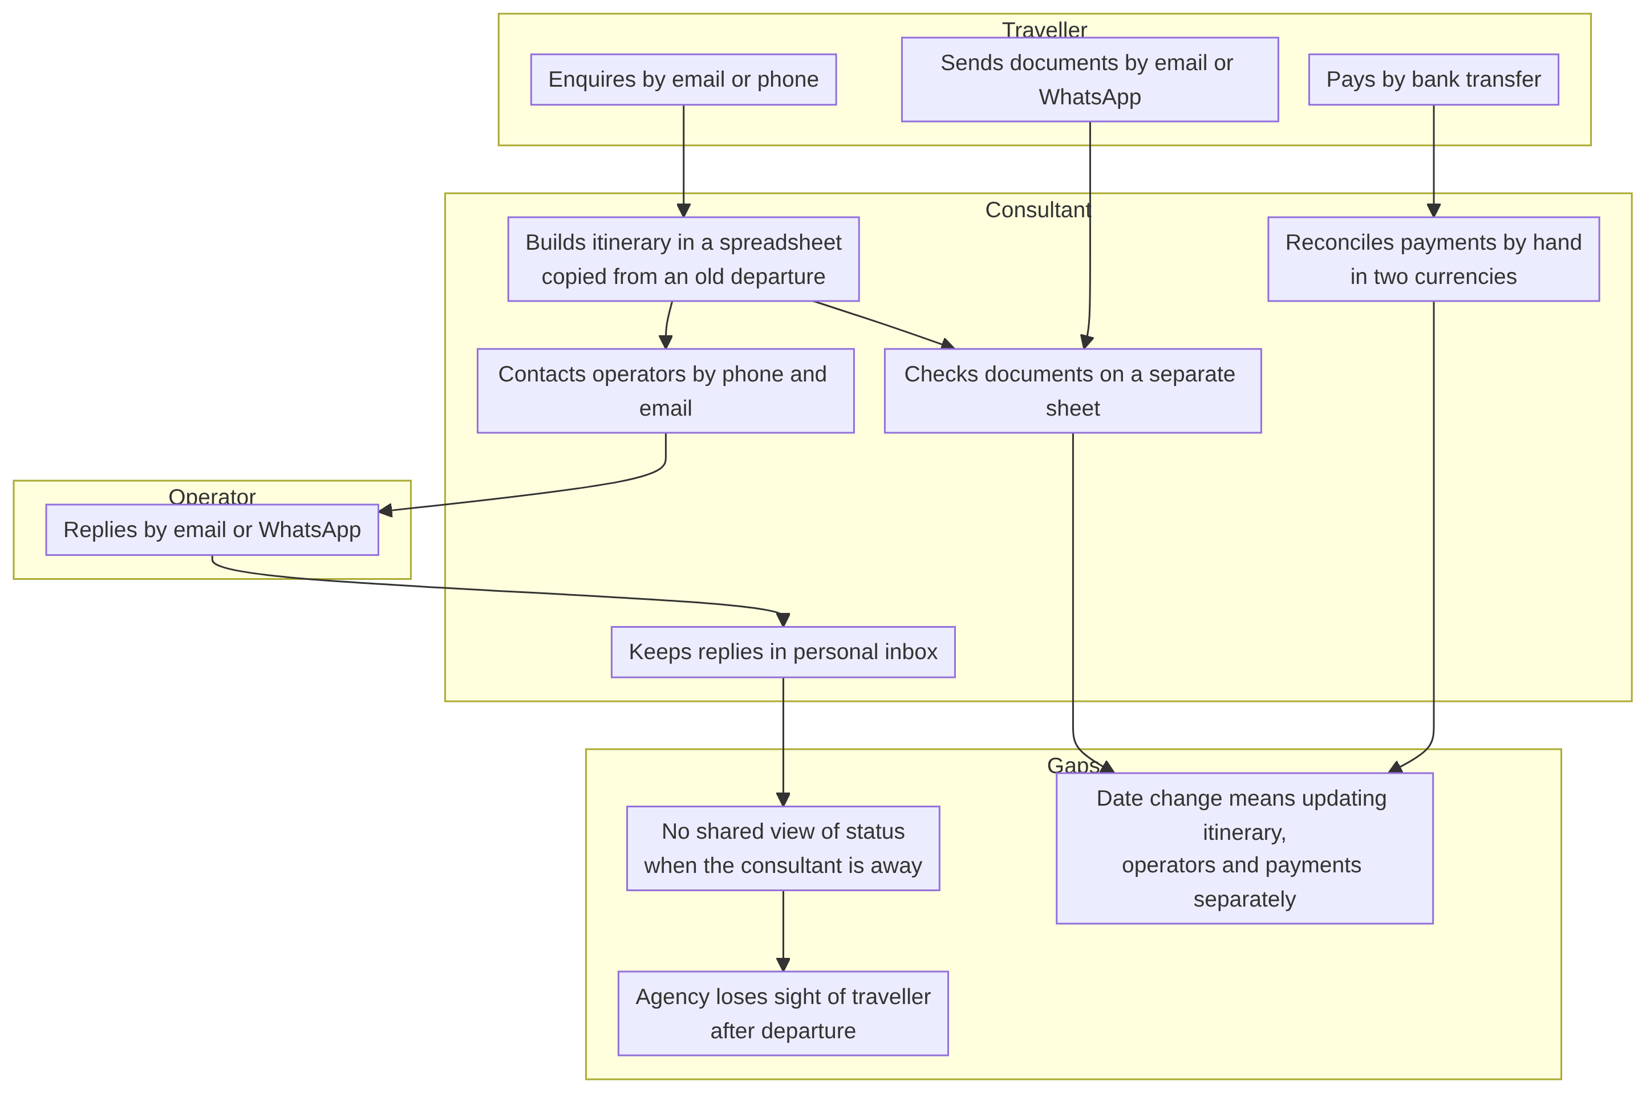
Figure 4: As-is process: spreadsheet, email and WhatsApp

To be process
In TrailAsia the same journey becomes one connected flow. A public enquiry creates a booking at once. The consultant quotes and confirms it, the coordinator raises operator confirmations and verifies documents, finance records payments, and the system computes readiness and generates tasks from the gaps. The traveller sees their own checklist and can share location or raise an SOS. The flow below is the enquiry-to-confirmed-booking path, with swimlanes for each role.

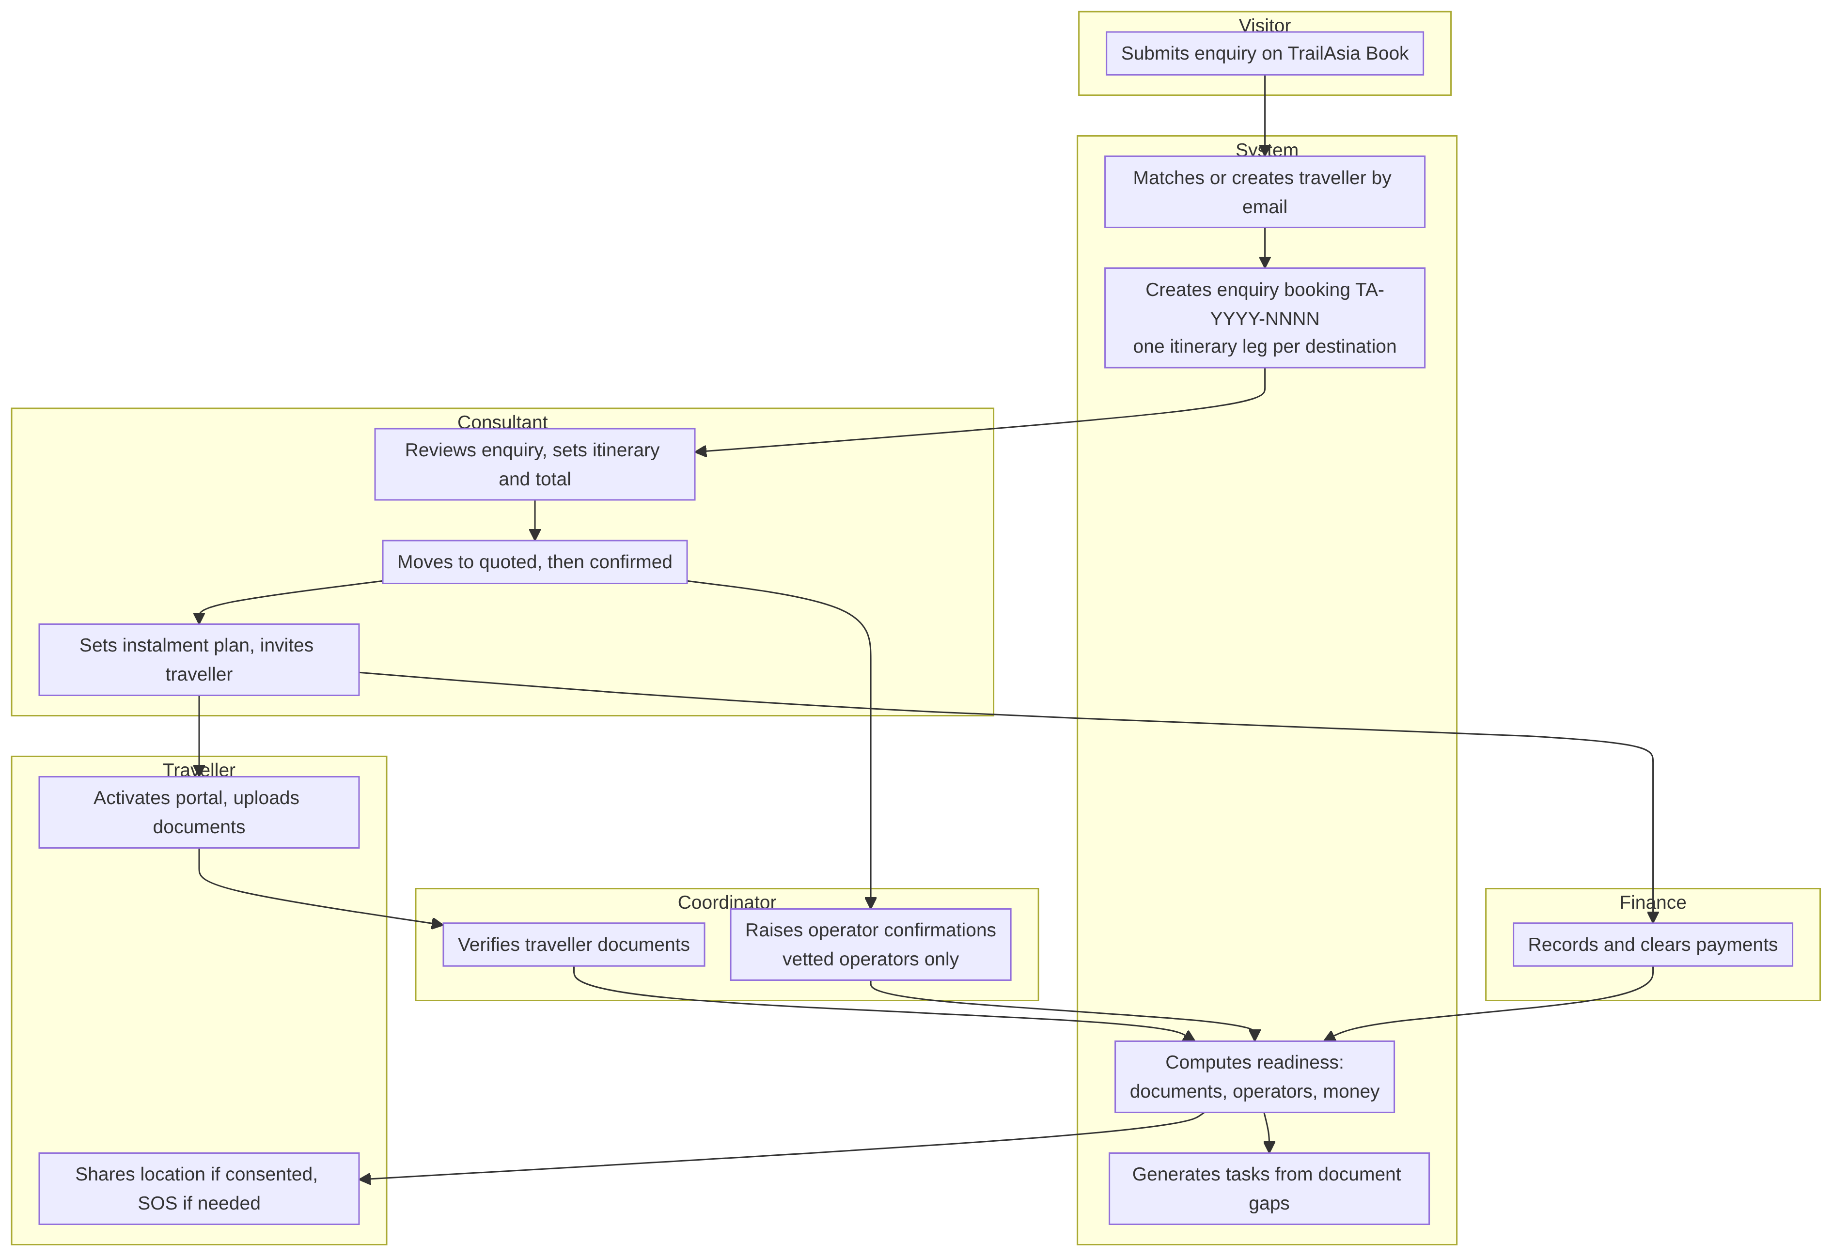
Figure 5: To-be process: enquiry to ready booking, by role

Other flows (portal activation, document upload and verification, operator confirmation, payments, SOS, location sharing, task generation and handover, sign-in and session refresh) are described step by step with their decisions in the reference document. The SOS flow and its life cycle are shown in the sequence and state diagrams that follow.

Domain model class diagram and description (Optional)
The domain model follows the entity-relationship diagrams in the next section. The central entity is the Booking, which has one consultant (mandatory) and one coordinator (optional), a party of Travellers through the associative entity BookingTraveller, and an ordered list of ItinerarySegments, each in one Destination. A Traveller holds TravellerDocuments that satisfy the DocumentRequirements of the destinations visited. A Booking has OperatorConfirmations (each with an Operator), PaymentSchedules (instalments) and Payments (the ledger), and Tasks with an append-only history. Safety is modelled as LocationConsent, LocationPing and SOSAlert with an append-only SOSAlertEvent log. Travellers, operators and staff are separate account types with no shared supertype.
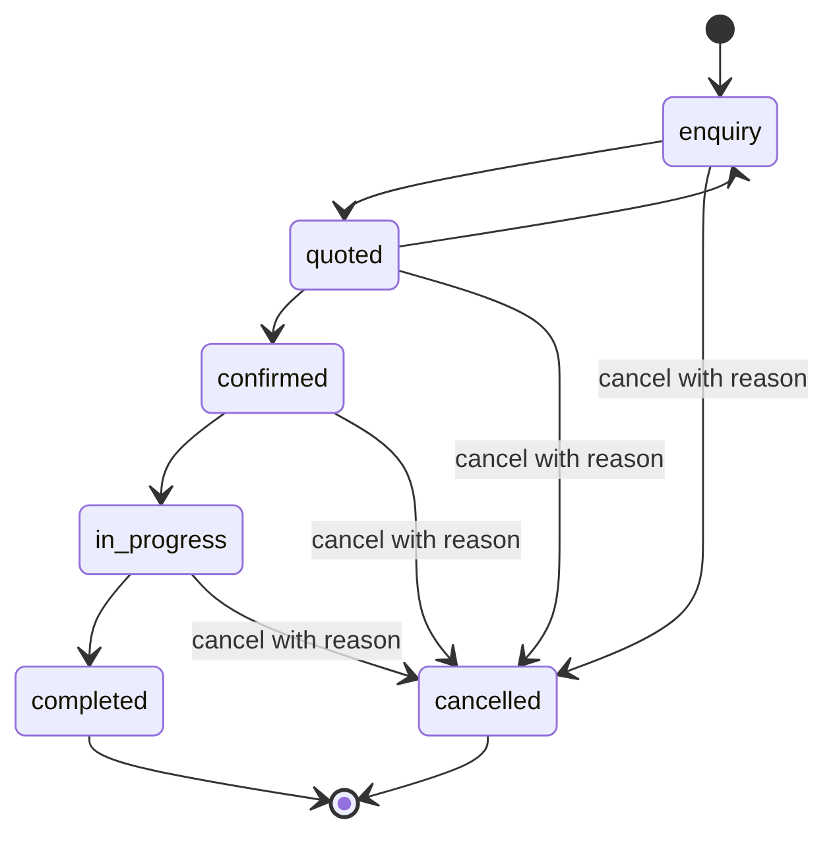
Figure 6: Booking status life cycle
Booking status moves only along the arrows. Cancelling needs a reason and is refused for completed bookings. Reports count confirmed, in-progress and completed bookings as won.

Sequence diagram and description (Optional)
The sequence below follows an SOS from the traveller's tap to resolution. Position capture waits up to 6 seconds and the alert is created either way. The notification service writes one notification and one email per trip editor, and a failure there cannot undo the alert. The traveller's app polls for status; the staff app polls the alert list every 30 seconds.

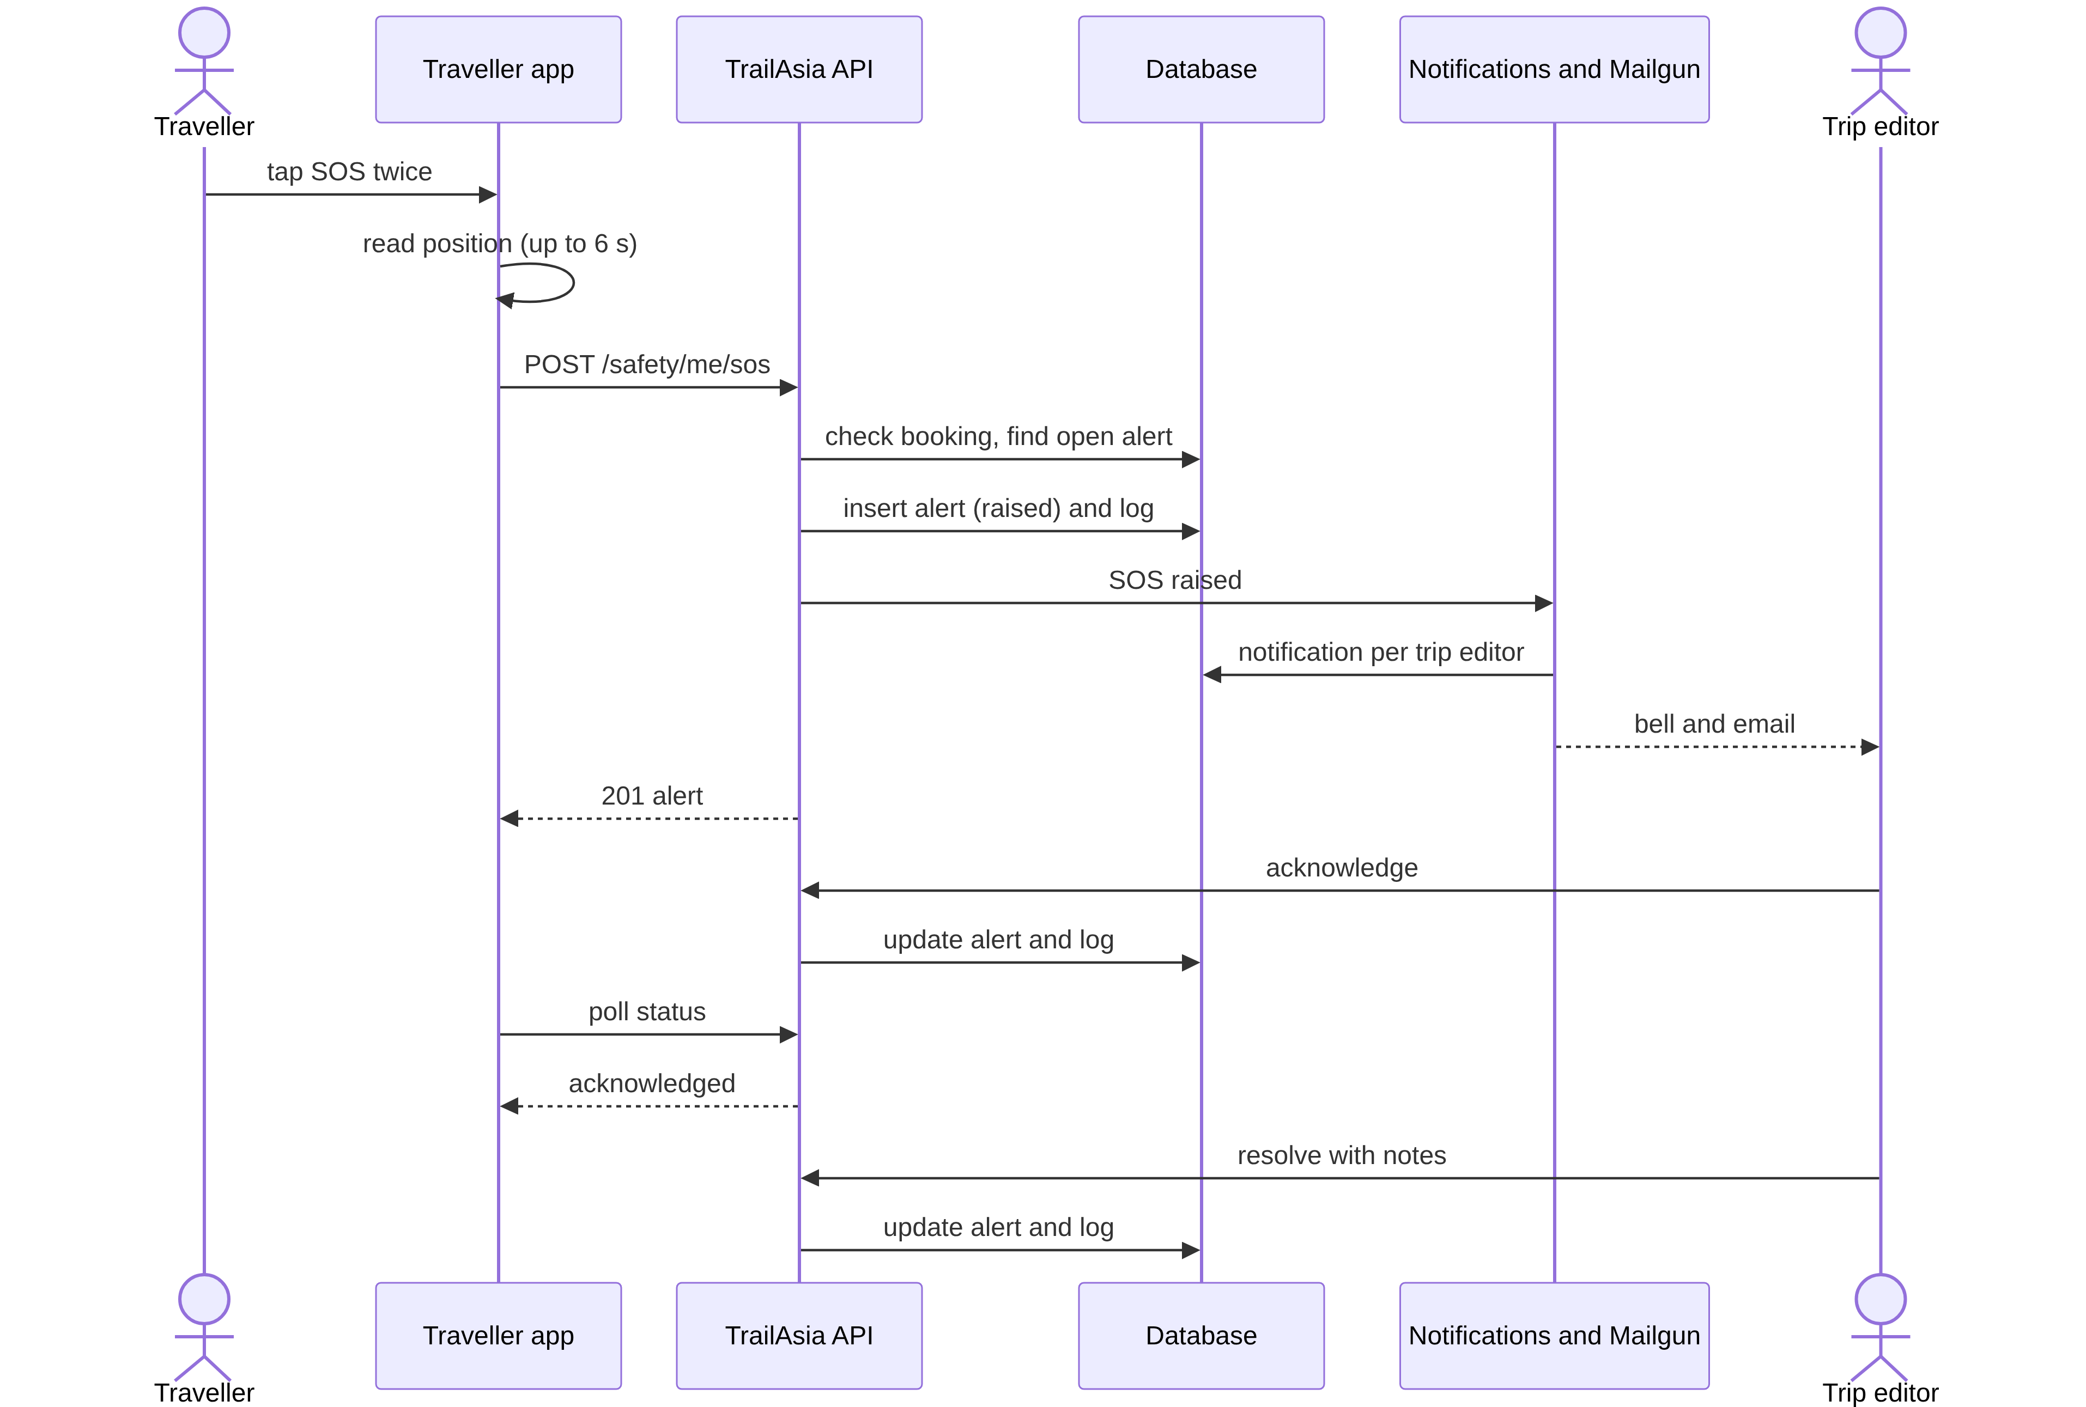
Figure 7: Sequence of an SOS from raise to resolution

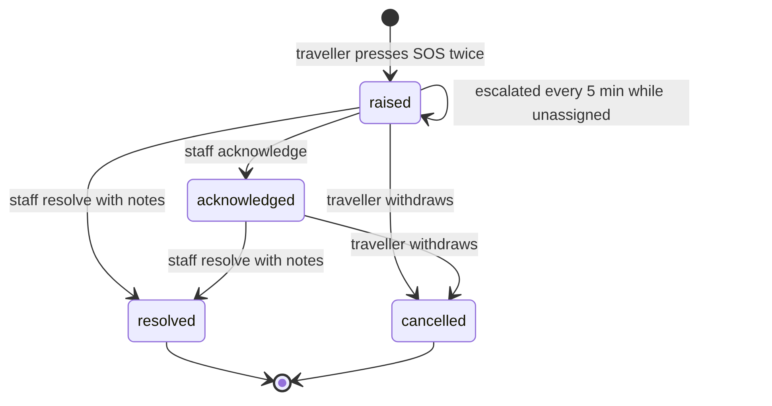
Figure 8: SOS alert life cycle
Nothing closes an alert automatically. Staff cannot cancel an alert and a traveller cannot resolve one. An alert still raised with nobody assigned is escalated to every trip editor every 5 minutes (the escalation job exists but is not yet scheduled).

Enterprise architecture
The system is a layered web application. Browsers (staff, traveller, operator and public visitor) talk to React front ends; the staff client holds three separate applications (staff portal, traveller portal at /trip, operator portal at /operator) with three separate sessions. All of them call one REST API, which holds every rule and all data. The API passes each request through a route, authentication and role middleware, request validation, a thin controller, a service holding the business rules, and a Sequelize model before reaching MySQL. Uploaded files live on the API server's disk. Mailgun sends email. TrailAsia Book has a small proxy server that serves the built site and forwards /api to the same API.

Data flow diagram level 0
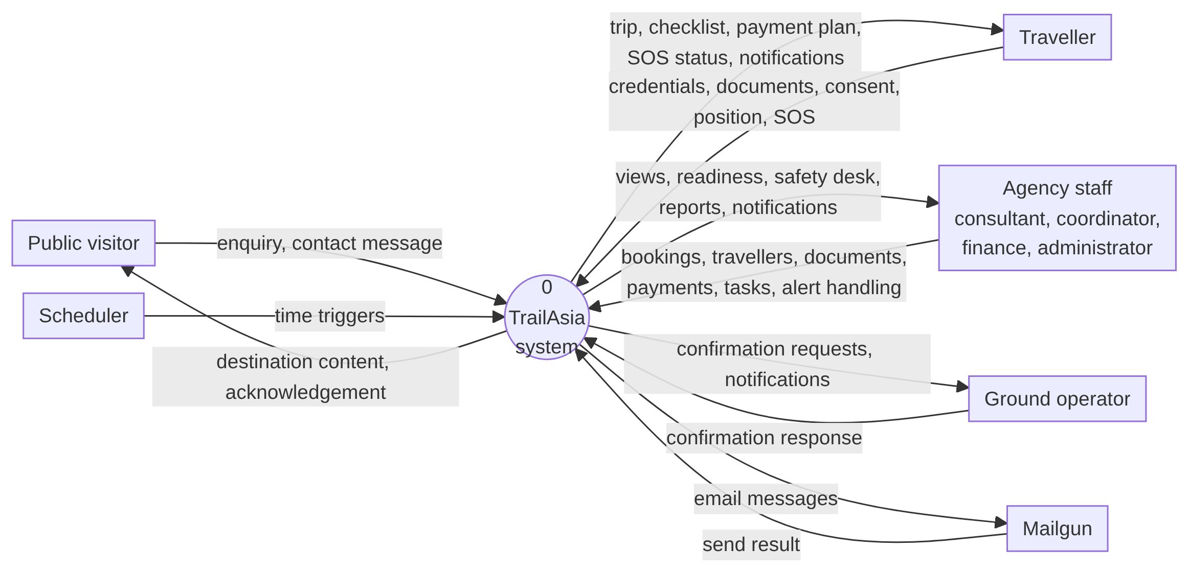
Figure 9: Context diagram (DFD level 0)

Data flow diagram level 1
Level 1 splits the system into eleven processes (names are shortened in the figure): accounts and sessions, destinations, public enquiries, travellers and documents, bookings and itineraries, ground operators, payments, tasks and handovers, traveller safety, notifications and reports. The 24 data stores are left off the figure for readability and are listed below with the stores each process reads and writes.

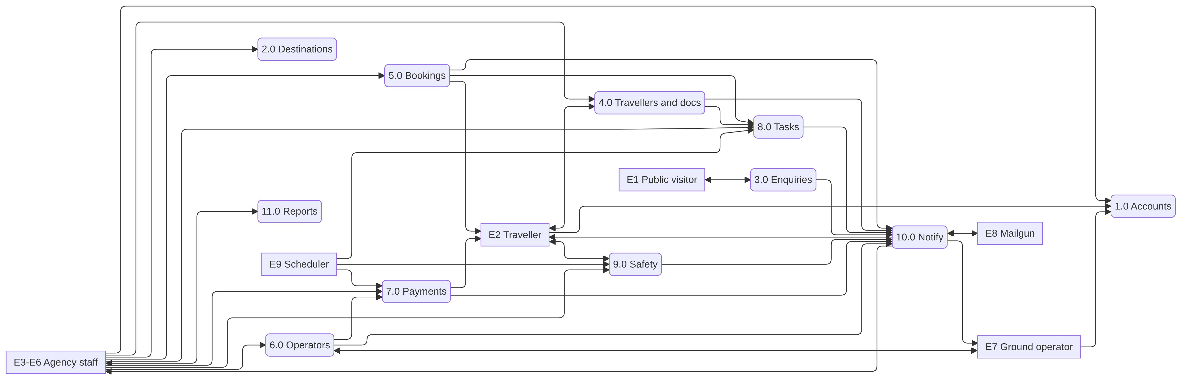
Figure 10: DFD level 1: processes and flows

Process | Reads | Writes
1.0 Accounts and sessions | Staff accounts, sessions, travellers, operators | Same
2.0 Destinations | Destinations, document requirements | Same
3.0 Public enquiries | Staff accounts, destinations, testimonials, travellers | Travellers, bookings, party, itinerary, contact messages
4.0 Travellers and documents | Destinations, requirements, travellers, documents, operator confirmations | Travellers, documents, document files
5.0 Bookings and itineraries | Staff, destinations, travellers, bookings, party, itinerary | Bookings, party, itinerary
6.0 Ground operators | Destinations, bookings, itinerary, operators, confirmations | Operators, confirmations
7.0 Payments | Bookings, confirmations, instalments, ledger | Instalments, ledger
8.0 Tasks and handovers | Staff, bookings, tasks, history | Tasks, history
9.0 Traveller safety | Staff, travellers, bookings, party, consents, pings, alerts, log | Consents, pings, alerts, SOS log
10.0 Notify people | Staff, travellers, operators, notifications, email log | Notifications, email log
11.0 Reports | Bookings, itinerary, operators, confirmations, instalments, ledger, tasks, destinations | None
Table 17: Data stores read and written by each level-1 process

ERD and description
The model has 23 tables. It is shown in three parts so each stays readable: bookings and travellers (core), operations (operators, payments and tasks) and safety and sessions. Crow's foot notation is used. A circle on the child side means the parent is optional.
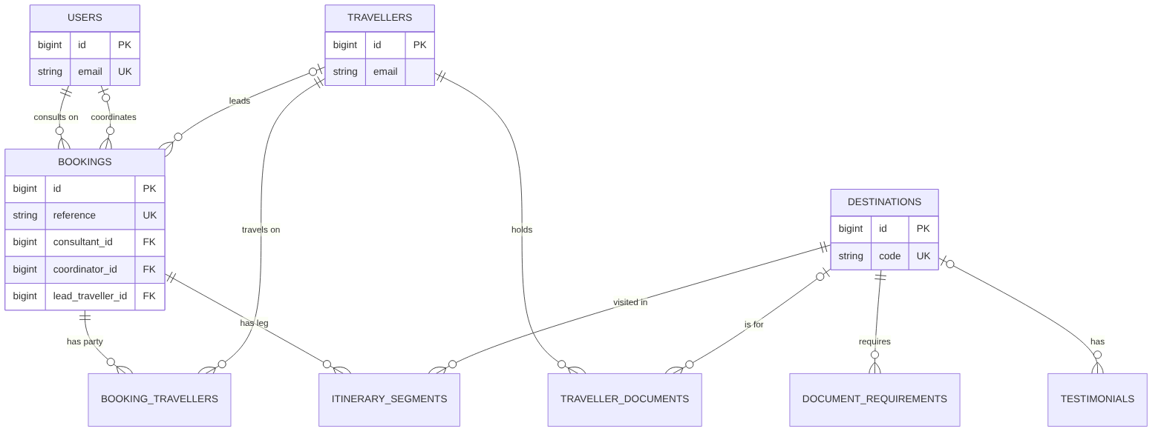
Figure 11: ERD part 1: travellers, bookings, itinerary and destinations
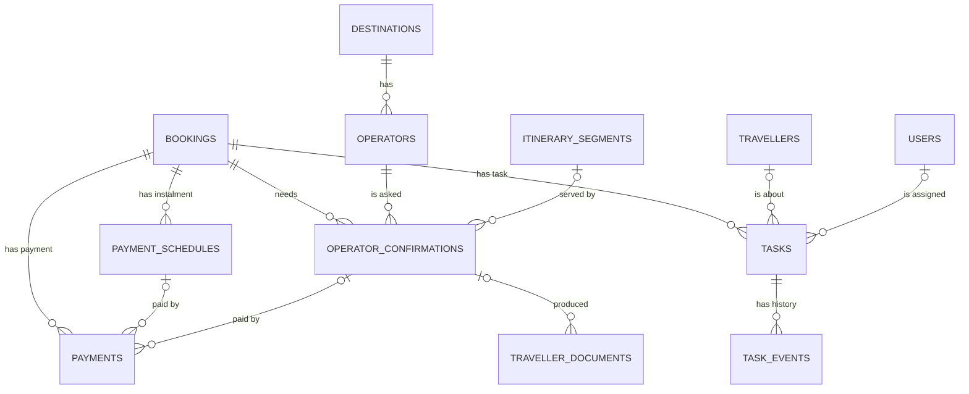
Figure 12: ERD part 2: operators, payments and tasks
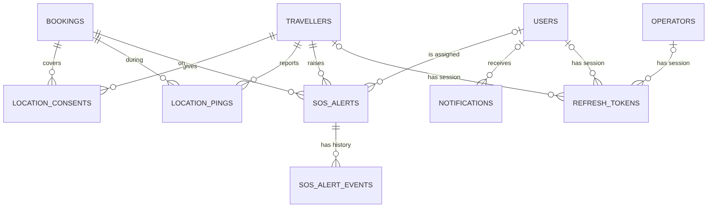
Figure 13: ERD part 3: safety, notifications and sessions
Points that affect how the model reads:
- Booking and Traveller are many-to-many through booking_travellers, which carries its own attributes (is_lead, notes). Booking and Destination are many-to-many through itinerary_segments (order, dates, altitude).
- Composite uniqueness prevents duplicates: a traveller appears once per booking, itinerary positions are unique per booking, consent is one row per traveller per booking, and a payment reference is unique per direction.
- One table, three kinds of owner. refresh_tokens and notifications each belong to exactly one of a staff user, a traveller or an operator.
- Audit links are not drawn. Most tables also record who created, updated, verified or resolved a row; these links to the users table are left out to keep the diagrams readable.
- Derived, not stored: a document's expired status, checklist items, whether an instalment is settled or overdue, a traveller's portal state, and all report figures.
- Weak entities: sos_alert_events, task_events, itinerary_segments, booking_travellers, document_requirements, payment_schedules and location_pings cannot exist without their parent.
- Standalone: contact_messages and email_logs have no foreign keys.
The tables are:
Table | Purpose | Key points
users | Staff accounts | Four roles; lockout fields; email unique
refresh_tokens | Sessions for staff, travellers and operators | Only the token hash is stored; one of three owner columns is filled
destinations | Countries sold, with travel-guide content | code unique; JSON lists for the public site
document_requirements | Documents a destination requires | Lead time, minimum passport validity, altitude cover
travellers | People who travel, with passport and portal sign-in | Portal columns on the same row; email not unique
traveller_documents | Documents a traveller holds | Status, optional file, optional link to an operator confirmation
bookings | One trip | Reference unique; six statuses; consultant mandatory
booking_travellers | Party members | Unique per booking and traveller
itinerary_segments | Ordered legs of a booking | Unique sequence per booking; highest altitude
location_consents | Consent to share location | One per traveller per booking; stores the agreed wording
location_pings | Recorded positions | Deleted 30 days after the trip
sos_alerts | Emergency alerts | Four statuses; assignment, acknowledgement and resolution fields
sos_alert_events | SOS log | Append-only; never holds coordinates
tasks | Work items on a booking | Manual or generated from a document gap
task_events | Task history | Append-only
notifications | In-app messages | 21 types; unique dedupe key per recipient
operators | Ground operators | Vetting fields; portal sign-in columns
operator_confirmations | Requests to an operator and the answer | Five statuses; quoted amount and currency
payment_schedules | Instalments | No paid column; computed from payments
payments | Ledger of money in and out | Currency, rate and base amount fixed at entry
testimonials | Published traveller quotes | Optional destination
contact_messages | Messages from the public site | No links to other tables
email_logs | Each email attempt | sent, failed or skipped
Table 18: The 23 tables

Data dictionary
Types are MySQL types. Every table also has created_at and updated_at (required). PK is a primary key, FK a foreign key, UQ unique. The dictionary below covers the six tables that carry the most important data. The column-level dictionary for all 23 tables is in the reference document and can be added as an appendix.

users (staff)
Column | Type | Req. | Key / values
id | BIGINT UNSIGNED | yes | PK, auto-increment
first_name, last_name | VARCHAR(100) | yes
email | VARCHAR(255) | yes | UQ
password_hash | VARCHAR(255) | yes | bcrypt hash
role | ENUM | yes | consultant, coordinator, finance, admin; default consultant
is_active | BOOLEAN | yes | default true
last_login_at | DATETIME | no
failed_login_attempts | INTEGER UNSIGNED | yes | default 0
locked_until | DATETIME | no | lock for 15 minutes after 5 failures

travellers
Column | Type | Req. | Key / values
id | BIGINT UNSIGNED | yes | PK
first_name, last_name | VARCHAR(100) | yes
email | VARCHAR(255) | no | not unique
phone | VARCHAR(40) | no
date_of_birth | DATE | no
nationality, passport_country | CHAR(2) | no
passport_number | VARCHAR(60) | no | masked in lists and for finance
passport_expiry | DATE | no
emergency_contact_name / phone / relationship | VARCHAR(160/40/60) | no
dietary_notes, medical_notes | TEXT | no | medical notes are sensitive information
created_by_user_id | BIGINT UNSIGNED | no | FK to users; this staff member is notified about documents
is_active | BOOLEAN | yes | default true
password_hash | VARCHAR(255) | no | portal password
portal_enabled | BOOLEAN | yes | default false
invite_token_hash, invite_expires_at, invite_sent_at | CHAR(64), DATETIME | no | one-time 72-hour invitation, hash only
portal_activated_at, last_login_at | DATETIME | no
failed_login_attempts, locked_until | INTEGER, DATETIME | yes / no | lockout

bookings
Column | Type | Req. | Key / values
id | BIGINT UNSIGNED | yes | PK
reference | VARCHAR(20) | yes | UQ, like TA-2026-0007
title | VARCHAR(200) | yes
status | ENUM | yes | enquiry, quoted, confirmed, in_progress, completed, cancelled; default enquiry
consultant_id | BIGINT UNSIGNED | yes | FK to users; deletion refused
coordinator_id | BIGINT UNSIGNED | no | FK to users
lead_traveller_id | BIGINT UNSIGNED | no | FK to travellers
departure_date, return_date | DATE | no
party_size | INTEGER UNSIGNED | yes | default 1
currency_code | CHAR(3) | yes | default AUD; base currency for payments
total_amount, deposit_amount | DECIMAL(12,2) | no
notes | TEXT | no
cancelled_at, cancellation_reason | DATETIME, VARCHAR(500) | no | reason required to cancel
created_by_user_id | BIGINT UNSIGNED | no | FK to users

traveller_documents
Column | Type | Req. | Key / values
id | BIGINT UNSIGNED | yes | PK
traveller_id | BIGINT UNSIGNED | yes | FK to travellers
destination_id | BIGINT UNSIGNED | no | FK to destinations; empty for a passport
type | ENUM | yes | passport, visa, insurance, health_declaration, permit, vaccination, other
reference, issuer | VARCHAR(120/160) | no
issued_on, expires_on | DATE | no | expired status is computed
status | ENUM | yes | outstanding, submitted, verified, rejected; default outstanding
altitude_cover_metres, insurer_contact_phone | INTEGER, VARCHAR(40) | no | for insurance
verified_by_user_id, verified_at | BIGINT, DATETIME | no | who verified or rejected
notes | TEXT | no
file_path / stored_file_name, original_file_name, file_mime_type, file_size_bytes | VARCHAR, INTEGER | no | external link or uploaded file under a random name
operator_confirmation_id | BIGINT UNSIGNED | no | FK; permit from an operator

sos_alerts
Column | Type | Req. | Key / values
id | BIGINT UNSIGNED | yes | PK
traveller_id, booking_id | BIGINT UNSIGNED | yes | FK; deletion refused
status | ENUM | yes | raised, acknowledged, resolved, cancelled; default raised
raised_at | DATETIME | yes
latitude, longitude | DECIMAL(9,6) | no | only if the phone had a position
accuracy_metres | INTEGER UNSIGNED | no
message | VARCHAR(500) | no
acknowledged_at, acknowledged_by_user_id | DATETIME, BIGINT | no | FK to users
resolved_at, resolved_by_user_id, resolution_notes | DATETIME, BIGINT, TEXT | no | notes required
cancelled_at | DATETIME | no
assigned_to_user_id, assigned_at, assigned_by_user_id | BIGINT, DATETIME | no | current owner

payments
Column | Type | Req. | Key / values
id | BIGINT UNSIGNED | yes | PK
booking_id | BIGINT UNSIGNED | yes | FK
payment_schedule_id | BIGINT UNSIGNED | no | FK; instalment paid
operator_confirmation_id | BIGINT UNSIGNED | no | FK; operator paid
direction | ENUM | yes | incoming, outgoing; default incoming
method | ENUM | yes | bank_transfer, card, cash, cheque, agent_credit, other
status | ENUM | yes | pending, cleared, failed, refunded; default pending
currency_code, amount | CHAR(3), DECIMAL(12,2) | yes | as paid
base_currency_code, exchange_rate, amount_in_base | CHAR(3), DECIMAL(16,8), DECIMAL(12,2) | yes | fixed at entry, never recomputed
reference | VARCHAR(120) | no | unique with direction
received_on | DATE | yes
cleared_at, settled_reason, notes | DATETIME, VARCHAR, TEXT | no | reason required for failed or refunded
recorded_by_user_id, updated_by_user_id | BIGINT UNSIGNED | no | audit

UXUI

Site map
The product has four front ends. Staff reach everything from a dashboard after signing in at /login; admin-only pages (staff accounts and the email log) are hidden from other roles. Travellers and operators each have their own sign-in and activation pages and never see staff screens. The routes for the staff portal, traveller portal and operator portal come from the application’s router; TrailAsia Book is a separate application and its pages are as designed for that site.
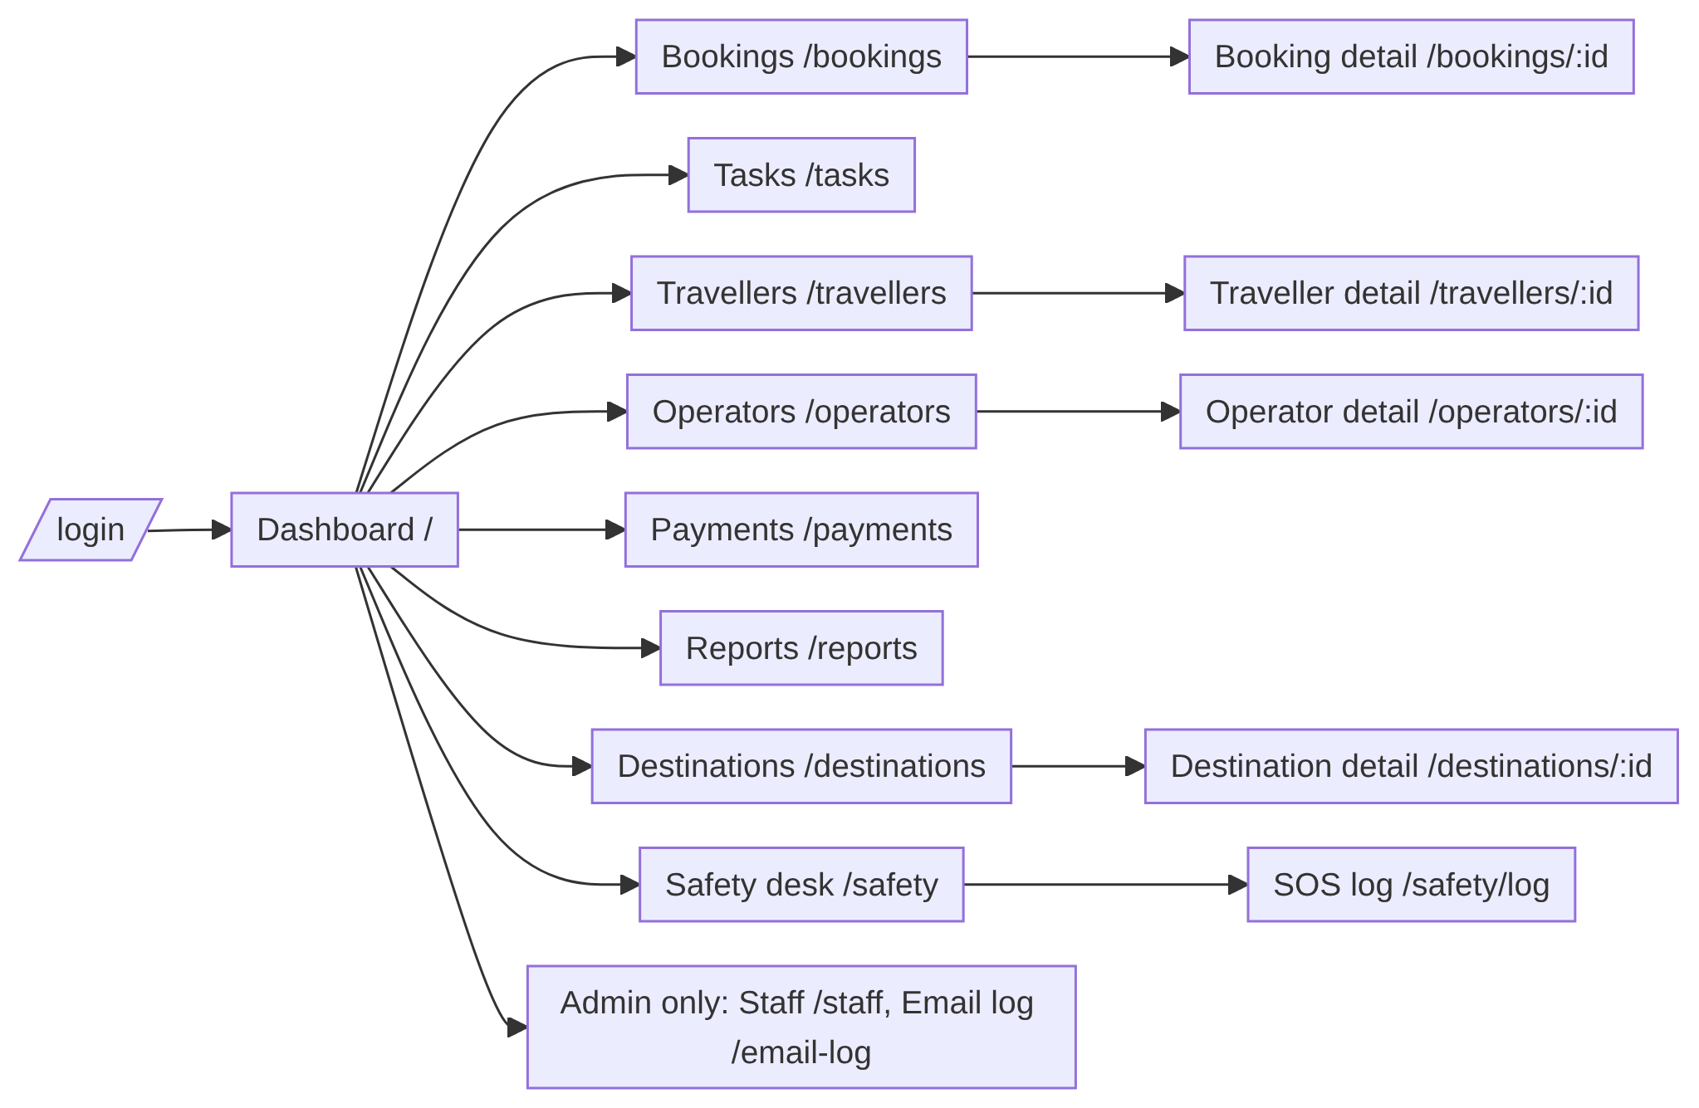
Figure 14: Site map of the staff portal
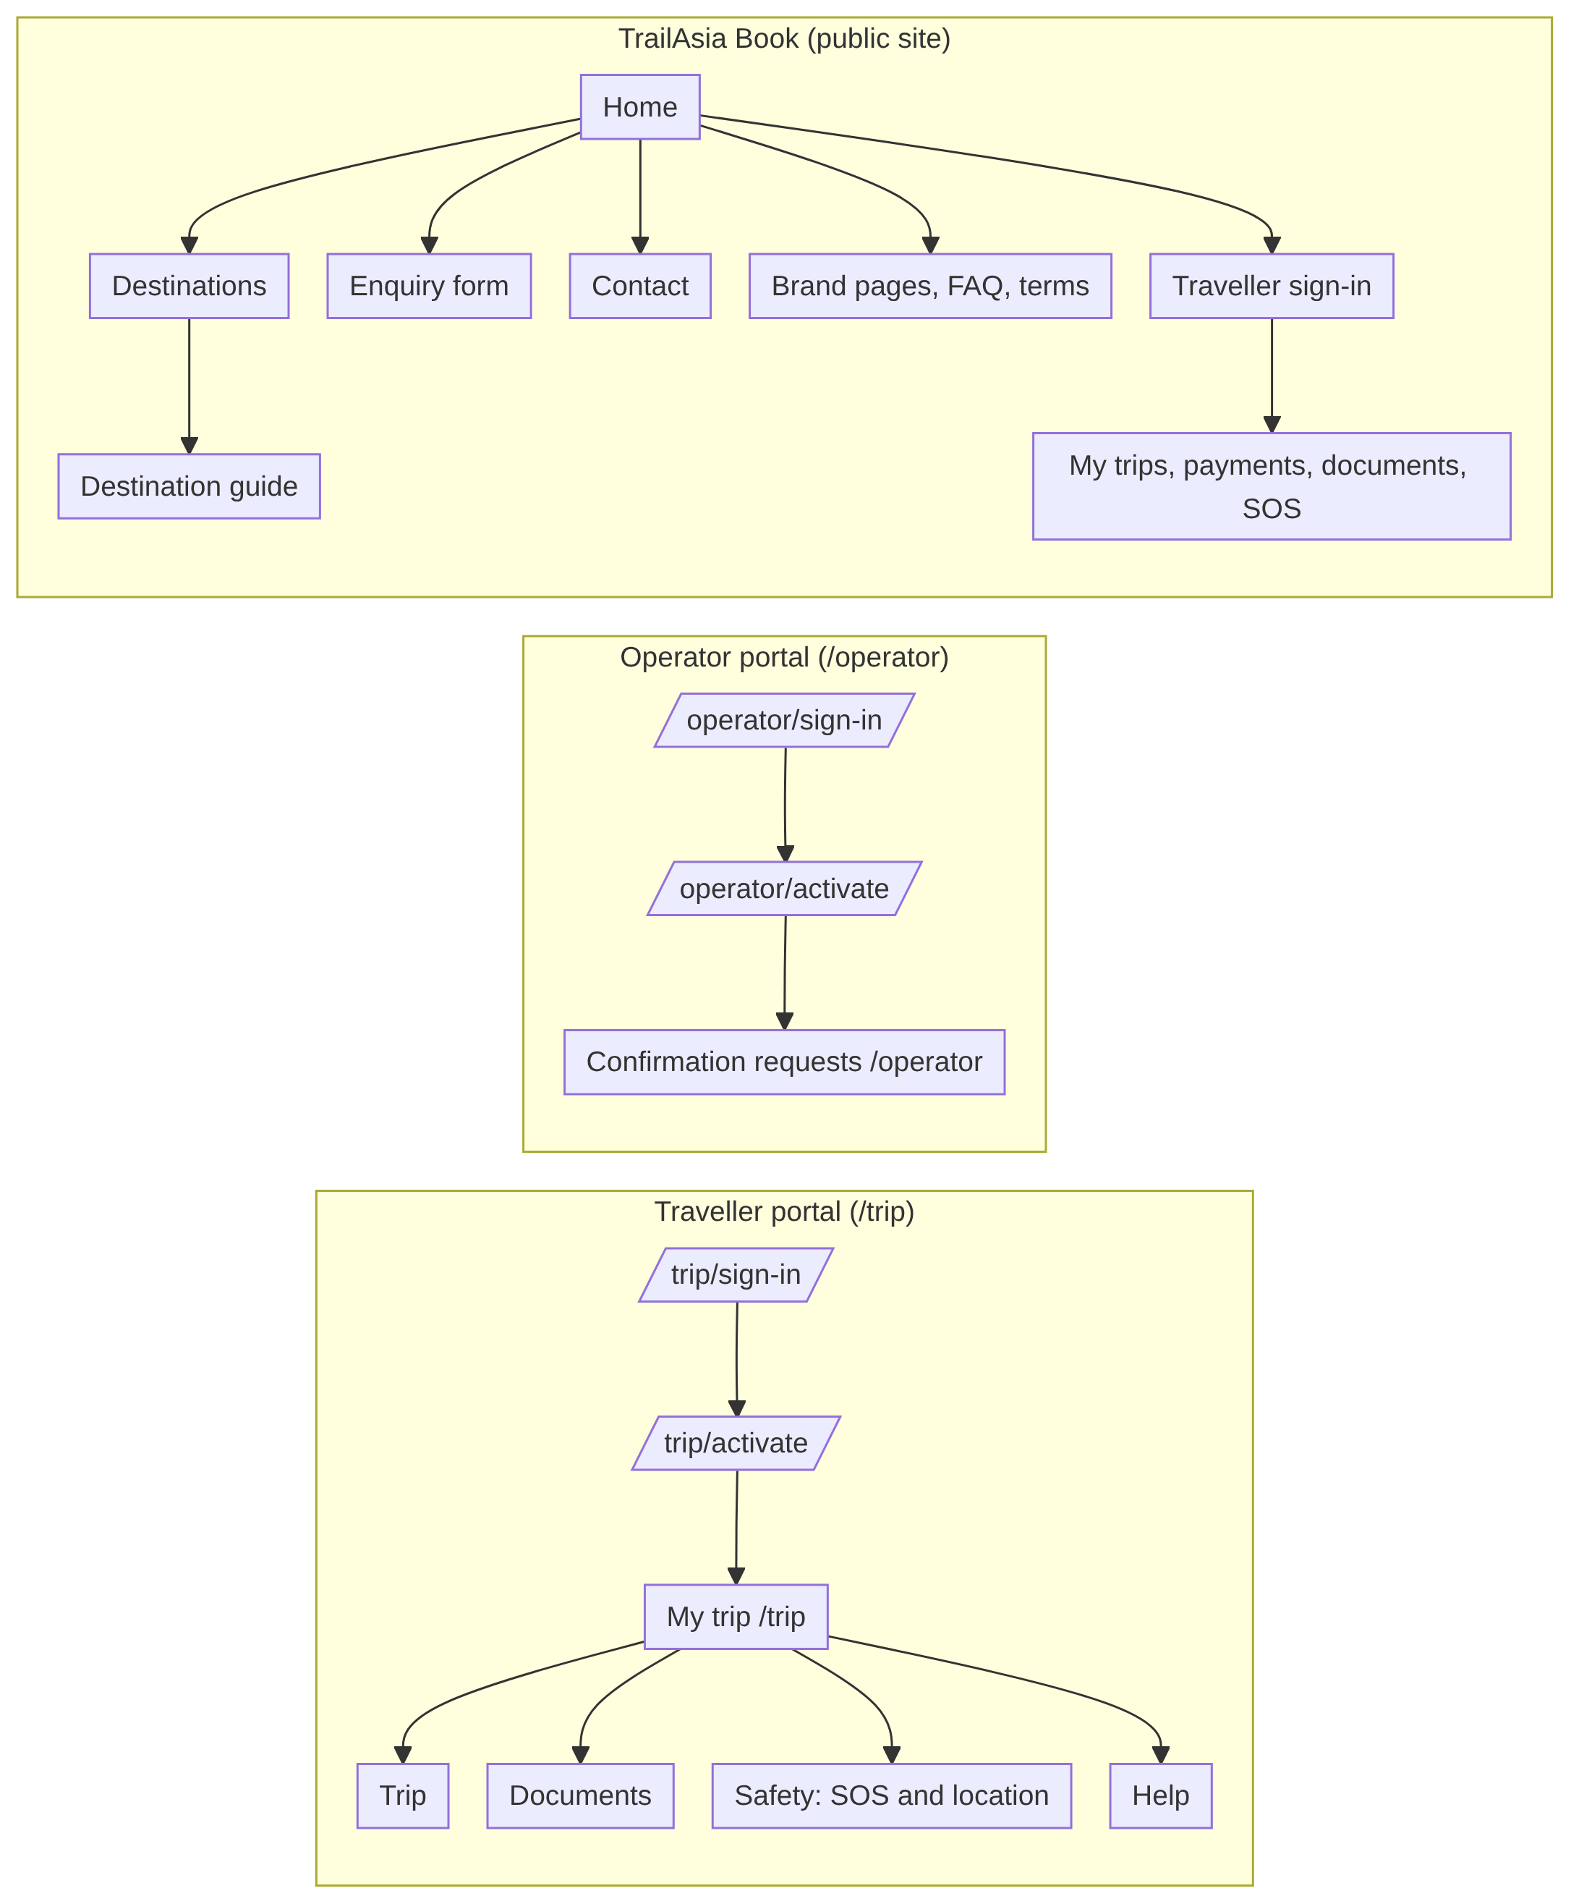
Figure 15: Site map of the traveller portal, operator portal and TrailAsia Book

Wireframe
The prototype was built directly in React with plain CSS rather than from wireframes. The table describes the main screens as built; the screenshots to insert beneath it show them.
Screen | Route | Purpose and main content
Dashboard | / | Pipeline totals, departure summary for the next 30 days, task and SOS counts
Bookings and booking detail | /bookings, /bookings/:id | List with filters; detail with party, itinerary, readiness (documents, operators, money) and status actions
Travellers and traveller detail | /travellers, /travellers/:id | Profiles, passport (masked in list), documents with upload, checklist, portal invitation
Operators and operator detail | /operators, /operators/:id | Directory, vetting, confirmations, portal invitation, chase list
Payments | /payments | Instalments, ledger, settle and waive actions, chase list
Tasks | /tasks | Shared queue, filters, assignment, status, handover
Safety desk and SOS log | /safety, /safety/log | Open alerts refreshing every 30 seconds with acknowledge, assign and resolve; full event log
Reports | /reports | Commercial and operational reports
Destinations | /destinations, /destinations/:id | Destinations and their document requirements
Staff and email log | /staff, /email-log | Admin only: staff accounts, email delivery log
Traveller portal | /trip | Phone-shaped app with four tabs: My trip, Documents (checklist and upload), Safety (consent, send position, SOS), Help
Operator portal | /operator | Own confirmation requests with confirm or decline, notifications
TrailAsia Book | separate site | Destinations, enquiry form, contact, brand pages, traveller sign-in, trips, documents, SOS
Table 19: Main screens as built
TO COMPLETE: insert a screenshot of each screen above (staff dashboard, booking detail with readiness, safety desk, traveller portal tabs, SOS armed and sent, document upload, operator portal, TrailAsia Book home and enquiry form). Screenshots need to be taken from the running application. If your brief asks for true wireframes, sketch the traveller portal and safety desk first.

User flow diagram
This flow follows a traveller from the invitation email through document upload and verification to the safety features. It combines the portal activation, document and SOS flows.
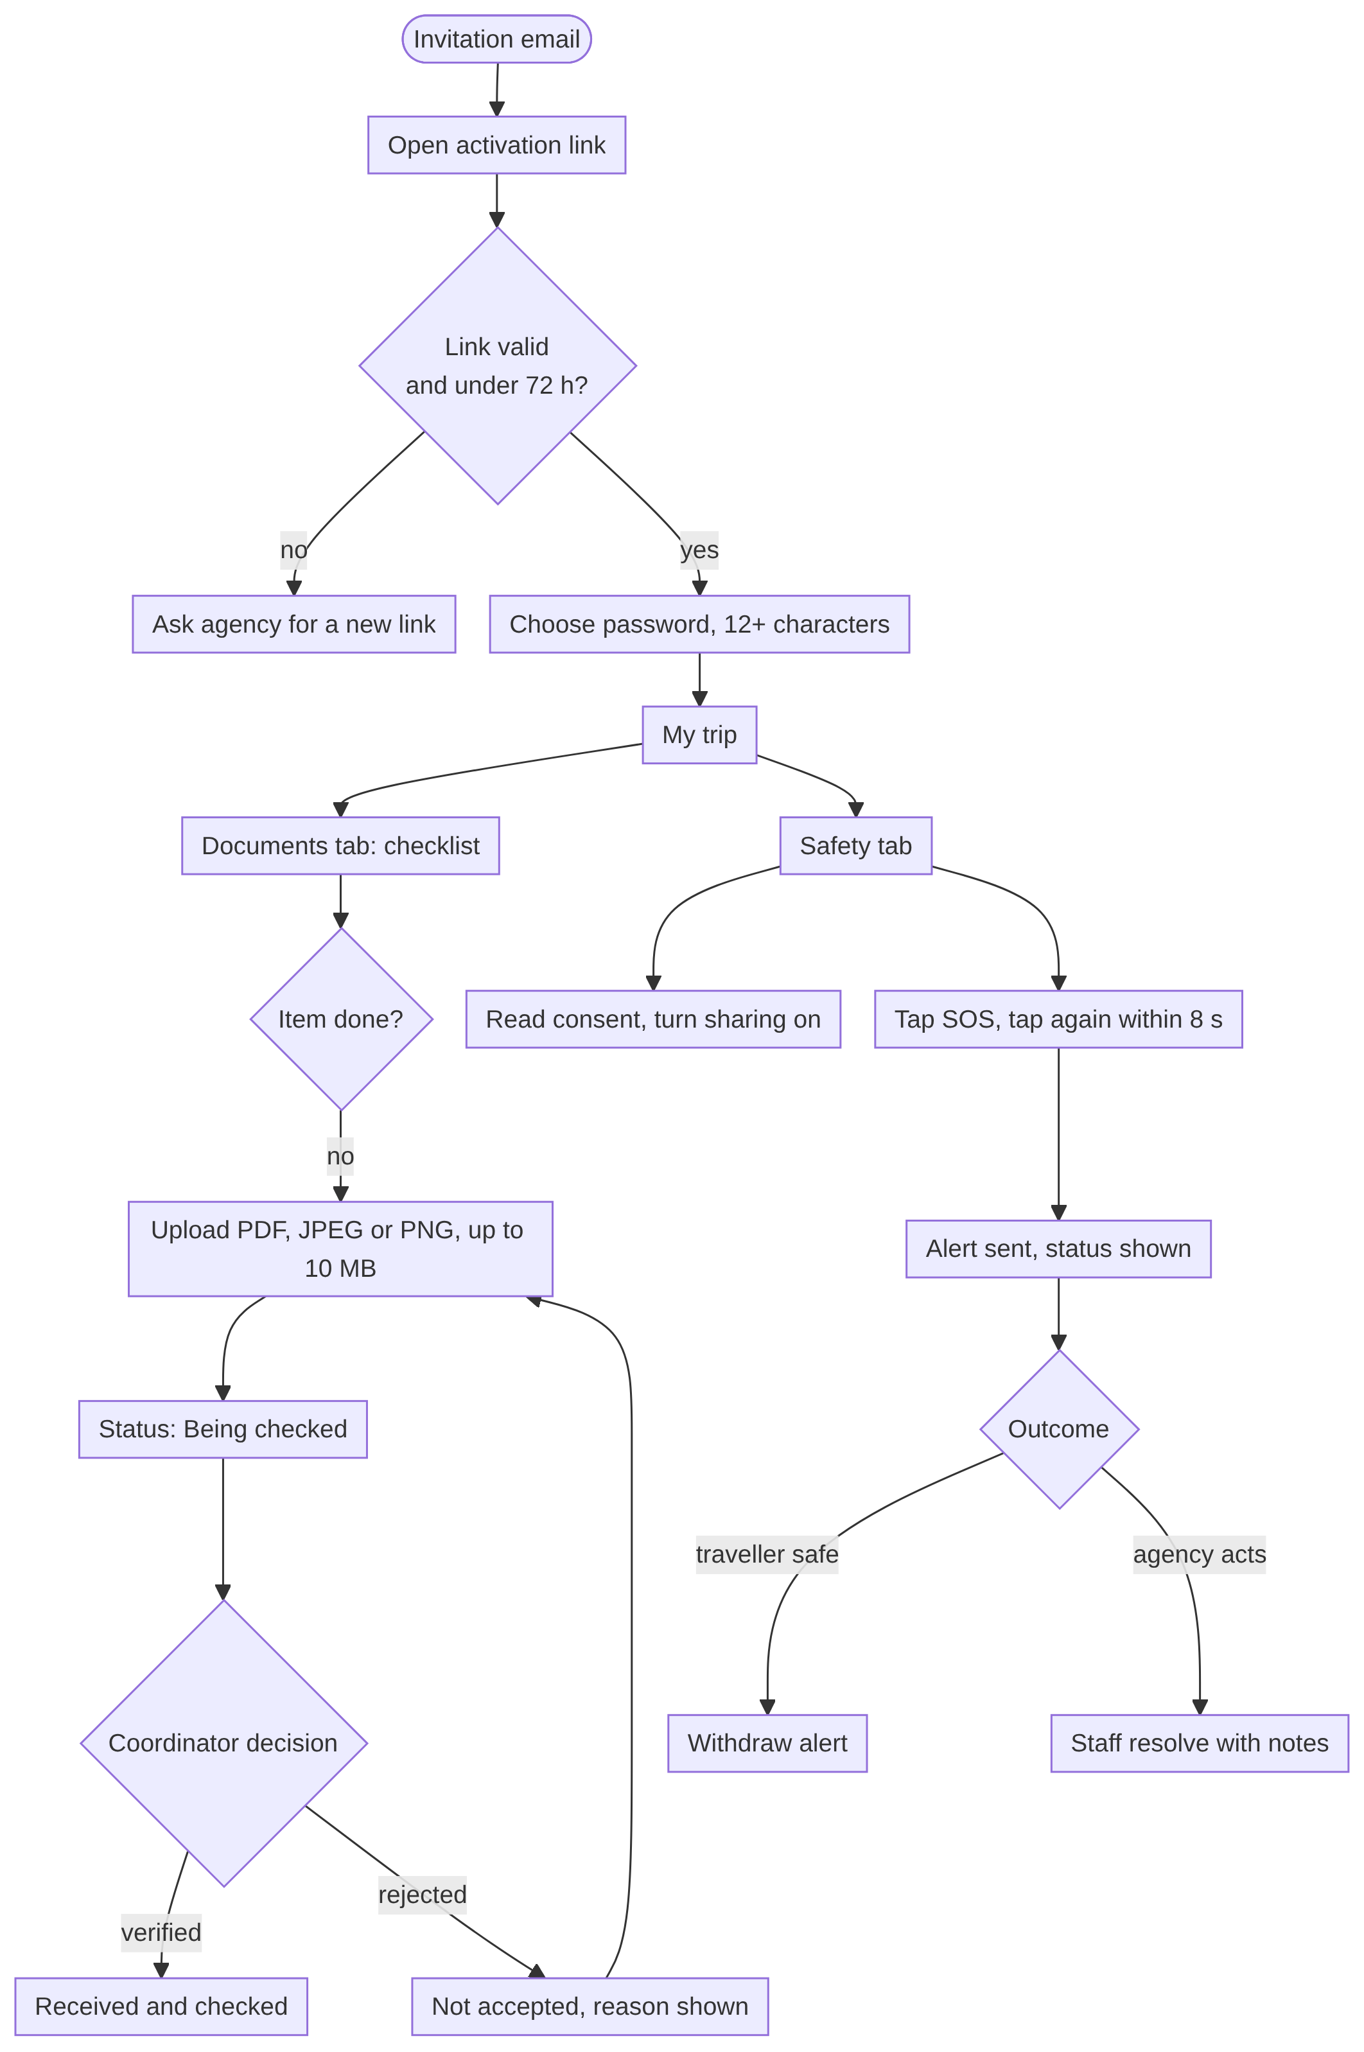
Figure 16: Traveller user flow: activation, documents and safety

User journey scenario (optional)
Scenario. Maya Collins has booked a three-week Nepal trek with a Bhutan extension. Her consultant confirms the booking and invites her to the portal. Maya activates her account from the email and sees a checklist showing her passport is on file but her insurance, Nepal visa and trekking permit are outstanding. She uploads insurance from her phone; the coordinator checks it, sees that the altitude cover is below the itinerary’s highest point and rejects it with a reason. Maya sees “Not accepted” with that reason and sends a corrected policy, which is verified. Before leaving she turns location sharing on for the trip. On day nine she is unwell, taps SOS twice, and the agency sees the alert with her last position. A coordinator takes it, calls her guide and resolves it with notes. (The traveller and her details are fictional and are used only to illustrate the flow.)

Prototype

Main components and functionalities
Component | What it does | Runs on (development)
TrailAsia API | REST API at /api/v1: 156 endpoints (112 staff, 18 traveller, 9 operator, 17 without a session). All rules and data live here | localhost:4000
Staff portal | Bookings, travellers, documents, operators, payments, tasks, safety desk, reports, staff accounts | localhost:5173
Traveller portal (/trip) | Phone-first: trip, documents with upload, safety (consent, position, SOS), help | localhost:5173/trip
Operator portal (/operator) | Operator confirms or declines requests; notifications | localhost:5173/operator
TrailAsia Book | Public site plus a second route into the traveller account | localhost:5174
MySQL database | 23 tables, 42 migrations | local
Mailgun | Email copies of notifications and invitations (optional) | external
Table 20: Prototype components
The most important functions to demonstrate are:
- A public enquiry arrives as an enquiry-stage booking assigned to an intake consultant, with a notification.
- A consultant builds the party and a multi-country itinerary and sees live readiness (documents, operators, money).
- A traveller activates their portal account, uploads a document, and a coordinator verifies or rejects it.
- A coordinator raises an operator confirmation (vetted operators only); the operator answers in their own portal.
- Finance records a payment in another currency with a stored exchange rate and settles it; balances recompute.
- A traveller shares location with consent and raises an SOS; staff acknowledge, assign and resolve it; the SOS log shows every step.
The repository includes Windows setup and start scripts (setup.bat and start.bat) and API documentation under docs/api, with architecture decision records for authentication and for traveller sessions and location data.

Link of the prototype
TO COMPLETE: add the prototype link. The prototype currently runs only on a developer machine (localhost), which a marker cannot open. Provide a hosted URL, or the repository link with the setup steps and a short screen recording, plus demo logins for each role (consultant, coordinator, finance, admin, a traveller and an operator). Do not include real passwords in a submitted report if the link is public.

Development

Requirement matrix
The matrix traces each business requirement to the functional requirements that deliver it, the build status, and the automated test suites that cover the area. Suites are named by file.
Business requirement | Delivered by | Status | Covering test suites
BR-1 One system for bookings, documents, operators, payments | FR-5 to FR-11 | Built | bookings, travellers, operators, payments
BR-2 Build an itinerary once | FR-7 | Built (no itinerary templates) | bookings
BR-3 Documents against destination requirements | FR-3, FR-5, FR-6 | Built | destinations, travellers, documentUploads
BR-4 Operator confirmations on the booking | FR-8, FR-9 | Built | operators, operatorAuth, operatorPortal
BR-5 Multi-currency payments | FR-10 | Built (manual ledger, no gateway) | payments
BR-6 Reach and locate travellers with consent | FR-12, FR-13 | Built (bell and email only; no SMS) | safety, travellerAuth, notifications
BR-7 Pipeline and demand visibility | FR-14 | Built (no export) | reports
BR-8 Privacy and data protection | FR-1, FR-4, FR-12; NFR-1 to 3 | Partly built (no MFA, no encryption at rest) | auth, travellers, safety, migrations
BR-9 Separation of duties | FR-5, FR-10; role matrix | Built | travellers, payments, users
BR-10 Insurance and altitude verification | FR-5, FR-6 | Built | travellers
After-hours chatbot (business case 4.2) | FR-17 | Not built | none
Fair-price guide and scam alerts (4.3) | FR-16 | Not built | none
Online payment gateway (4.2) | FR-18 | Not built | none
Table 21: Requirement matrix
Roles and permissions (consultant, coordinator, finance, admin) are enforced on the server for every request. Two separations of duty are deliberate (business case 8.2): the consultant who records a document cannot verify it, and the consultant who sold a trip cannot record that it was paid.

Benefit realisation
The business case sets targets that can only be measured once the system is in use at the agency, against baselines taken in discovery. We did not take baselines or run a pilot, so none of these has been achieved or measured. The table shows what the prototype provides to make each target measurable.
Benefit | Target (business case 9) | Measured by | What the prototype provides
Consultant efficiency | 30% less median time per multi-country booking | Time study before and at six months | One-time itinerary build, party, readiness view, generated tasks
Documentation | 95% of travellers complete 14 days before departure | Checklist reporting | Checklist and readiness, departure board, overdue flags
Reconciliation | 50% less finance time reconciling deposits | Finance time records | Instalment plan against ledger; computed paid and overdue; chase list
App adoption | 60% of departing travellers activate | Activation rate per departure | Portal access state per traveller (invited, active, suspended); needs a report
Insurance verification | 90% of trekking travellers verified before departure | Traveller records | Insurance with altitude check on the checklist
After-hours service | 70% of overnight enquiries resolved without a consultant | Chatbot logs | Not available (chatbot not built)
Escalation integrity | 100% of safety messages escalated to a human | Monthly escalation audit | SOS always raises an alert with a log; no chatbot
Security | No unresolved critical penetration-test finding | Independent test report | Not done
Table 22: Benefits, targets and evidence
Several of these can be reported from data the system already holds (for example documentation completeness and overdue instalments); adoption would need a small additional report.

Jira project set up (Optional)
Not used. Work was organised through phase documents in the project workspace and Git history.

Confluence set up (Optional)
Not used. Documentation lives in the repository (README, docs/api, docs/architecture) and the project workspace.

Testing

Test Plan

Testing approach and methodology
- Automated API tests. Jest with Supertest drives the real Express application through HTTP. 472 tests in 21 suites cover validation, permissions, business rules and response shapes. They run against an in-memory SQLite database so they are fast and repeatable.
- Database check. Because SQLite does not prove the MySQL schema, one suite (migrations) scans every migration for a known MySQL pitfall. A real defect of this kind was found and fixed: a column meant to be optional had stayed mandatory on MySQL, which broke traveller and operator sign-in.
- Browser walk-throughs. The SOS flow, document upload and SOS log were run in a real browser against the API.
- Not done: load, penetration, accessibility and usability testing with real travellers or staff.

Resource and environment requirements
Item | Requirement
Runtime | Node.js 20; npm; Git
Automated tests | No database server needed (in-memory SQLite); run from the server folder with the test script
Manual tests | MySQL 8 with migrations and seed data applied; API on port 4000; staff client on 5173; TrailAsia Book on 5174; a modern browser; for email tests, Mailgun key and domain (otherwise sends are logged and skipped)
Test data | Seeded users for each role, a destination with document requirements, a booking with a traveller and itinerary, a vetted operator
Table 23: Test environment

Roles and responsibilities
Role | Responsibility | Name
Test lead | Owns the plan and the pass or fail record | [assign]
Developers | Write and maintain automated tests for their module; fix defects | all four team members
Manual testers | Run the cases below in a browser and record results and screenshots | [assign]
Reviewer | Checks results against requirements before submission | [assign]
Table 24: Testing roles
TO COMPLETE: assign names and dates to the roles and schedule in this section.

Schedule and milestones
The business case allows two weeks for the test stage (functional, security, privacy and recovery testing) and one week for the pilot. In the prototype, automated tests were written with each phase, so testing ran throughout the build. A final full run of the suite is the exit criterion for submission.
Milestone | Exit criterion
Each phase | New tests written and the full suite passes
Before submission | All 472 tests pass; manual cases executed and recorded; open defects listed
Business case test stage (not run) | Security and privacy testing, recovery test, chatbot escalation scenarios
Table 25: Test milestones

Test cases
The cases below cover the rules that matter most to the business. Each can be run in the browser or by calling the API. The last column names the automated suite that already covers the area. The Result column is left for the tester to complete when running the case.
ID and title | Preconditions and setup | Test steps | Expected result | Suite | Result
TC-01 Account lockout | Active staff account | 1. Sign in with a wrong password 5 times  2. Sign in with the right password | Account locked for 15 minutes; message gives minutes remaining | auth
TC-02 Consultant cannot verify a document | Consultant signed in; a submitted document exists | Call verify on the document | Refused (forbidden); document unchanged | travellers
TC-03 Coordinator verifies, expiry blocks | Coordinator signed in; one valid and one expired document | 1. Verify the valid document  2. Verify the expired one | First becomes verified, consultant and traveller notified; second refused | travellers
TC-04 Public enquiry | Active destination; intake consultant exists | Submit the enquiry form with name, email, destination, dates, party size | Reference TA-YYYY-NNNN returned; enquiry booking with one leg; consultant notified | publicEnquiries
TC-05 Document upload limits | Traveller signed in to the portal | 1. Upload a 2 MB PDF  2. Upload an 11 MB file  3. Upload a .exe | PDF accepted as submitted; large and wrong-type files refused with a reason | documentUploads
TC-06 SOS needs no consent | Traveller on a booking, location sharing off | Raise SOS twice quickly; raise again | Alert raised; trip editors notified; second raise returns the same open alert | safety
TC-07 Position needs consent | Traveller on a booking | 1. Send a position with sharing off  2. Turn sharing on, send two positions 10 seconds apart | First refused; second two folded into one record | safety
TC-08 SOS escalation | Unassigned alert older than 5 minutes | Run the escalation job | Every trip editor re-notified; escalated event logged; repeats each 5 minutes until assigned or closed | safety
TC-09 Resolve needs notes | Open alert; trip editor signed in | Resolve with empty notes, then with 4 characters, then with a full note | First two refused; third resolves and is logged | safety
TC-10 Foreign-currency payment | Finance signed in; booking in AUD | 1. Record a USD payment without a rate  2. Record it with a rate  3. Record a duplicate reference | First refused; second stores rate and AUD amount; third refused as duplicate | payments
TC-11 Refund reopens instalment | Instalment fully paid by a cleared payment | Settle the payment as refunded with a reason | Instalment shows outstanding again; refund without a reason refused | payments
TC-12 Operator must be vetted | Unvetted operator | Raise a confirmation with that operator | Refused until the operator is vetted and active | operators
TC-13 Decline needs a reason | Operator signed in with a requested confirmation | Decline with no reason, then with a reason | First refused; second declines and notifies every trip editor | operatorPortal
TC-14 Task generation is repeatable | Booking with document gaps | Run sync tasks twice | One task per gap; second run changes nothing | tasks
TC-15 Handover | Staff A has open and done tasks | Hand over from A to B with a reason | Only open tasks move, each with a history entry; B receives one notification | tasks
TC-16 Session theft | Signed-in staff member | Use a refresh token twice | Second use ends every session for that person | auth
TC-17 Notification failure is harmless | Notification service made to fail | Raise an SOS or record a payment | The SOS or payment still succeeds | notifications
TC-18 Last admin protected | One active admin | Try to deactivate that admin | Refused | users
TC-19 Consultant sees own row only | Two consultants with bookings | Open the commercial report as one consultant | Only that consultant’s performance row is shown | reports
TC-20 MySQL schema | Migrations applied to MySQL | Sign in as an invited traveller and operator | Sign-in works (regression for the optional-column defect) | migrations
Table 26: Test cases
TO COMPLETE: run the cases above and fill in the Result column (pass or fail, date, tester), and add a final screenshot of the passing test run (472 tests in 21 suites). The Suite column names the area covered by an automated suite; confirm each case against that suite before claiming it is automated.

System implementation

System Implementation Planning
The business case proposes a pilot of one destination programme end to end, then a roll-out to the remaining destinations, with the old spreadsheets running in parallel until the pilot has completed a full booking-to-departure cycle without data loss. Before any pilot, the items under Limitation must be addressed, in particular hosting with HTTPS, a scheduler for the four jobs, backups, and multi-factor authentication.
Step | Activity | Exit check
1 | Host the API, database and front ends; configure HTTPS, backups and the scheduler | All four jobs run on time; backup restored once as a test
2 | Add multi-factor authentication for staff; run an independent penetration test | No unresolved critical finding
3 | Load the pilot destination’s data (destinations, document requirements, operators) | Coordinator signs off the data
4 | Train staff by destination programme | Champions confirm they can answer colleagues’ questions
5 | Pilot one destination; offer the portal to departing travellers | Full cycle completed without data loss
6 | Roll out remaining destinations; retire spreadsheets | Weekly feedback reviewed and significant issues fixed
Table 27: Implementation steps

Change management
- Observe consultants at work during discovery rather than relying on meetings.
- Name one senior consultant and one coordinator as champions.
- Run the spreadsheets in parallel until the pilot completes a full cycle without data loss.
- Train by destination programme, not by module, so training matches real work.
- State clearly that the system handles coordination and judgement stays with staff; in a 25-person agency, automation anxiety is a real adoption risk.
- Review pilot feedback weekly and fix significant issues before extending to other destinations.

Performance management
The prototype has not been run under load, so no performance figures are claimed. For a 25-person agency the expected load is small, but the safety desk polls every 30 seconds per open screen and travellers’ SOS pages poll every 15 seconds while an alert is open. Before go-live the team should measure response times for the main lists and reports (which are computed live from the operational tables), set targets, and monitor them. The business case sets recovery targets (RTO 4 hours, RPO 1 hour, faster for the safety module) that need infrastructure which does not exist yet.
Measure | Proposed target | How to monitor
API response time (lists, reports) | to be set after a measured baseline | Request timing logs; a simple load test before pilot
SOS to staff notification | seconds; alert visible on the desk within one 30-second refresh | Timestamps on alert, notification and email log
Unclaimed SOS escalation | no alert unclaimed for more than 5 minutes | Escalation events in the SOS log
Email delivery | failures visible and followed up | Email log (sent, failed, skipped)
Availability | RTO 4 h, RPO 1 h (safety module tighter) | Backup and restore test; uptime monitoring
Table 28: Performance and service measures

Security, disaster and contingency planning

Security
The business case (8.2) lists security and privacy requirements. The table compares each with what is built.
Requirement (business case 8.2) | Status | What is in place or missing
Encrypt in transit (TLS) and at rest | Gap | No deployment yet, so TLS is not configured; no encryption at rest
Multi-factor authentication for staff | Gap | Not built
Role-based permissions separating booking, finance and admin | Done | Four roles enforced on the server for every route; separation of duties for documents and payments
Location as a special category: consent, purpose, deletion | Done in code | Per-trip consent with stored wording; tap-to-send only; deleted 30 days after the trip; SOS log never stores coordinates. Deletion job not yet scheduled
No card data stored; PCI DSS gateway | Not applicable yet | No card data stored because payments are a manual ledger; gateway not built
Limit file types, scan uploads, control access to documents | Partly | Type and 10 MB size limit; random file names; download only through an authorised route. No virus scanning; type is taken from the browser
Audit log; watch unusual access | Partly | Task history and SOS log are append-only; payments record who entered or changed them; email log. No access-anomaly monitoring
Independent security testing before launch | Gap | Not done
Breach response plan (Notifiable Data Breaches) | Gap | Not written
Table 29: Security requirements against implementation
Controls that are in place and tested:
- Passwords hashed with bcrypt (cost 12), minimum 12 characters, lockout after 5 failures for 15 minutes.
- Short-lived access token held in memory; rotating refresh token in an httpOnly cookie, only its hash stored. Reuse of a rotated token ends every session for that person.
- Separate token scopes and guards for staff, travellers and operators.
- Sign-in gives the same answer and takes the same time whether or not an account exists. Other people’s records return “not found”, not “forbidden”.
- Every request body and query is validated by a schema; sort fields are checked against an allow-list; per-IP rate limits protect sign-in and the public forms.
- Passport numbers are masked in lists and for finance; password and invitation hashes are never returned.
- Operators see confirmation logistics, never a traveller’s documents.

Disaster Recovery Planning
The business case sets a recovery time objective of four hours and a recovery point objective of one hour, with tighter objectives for the safety module because it affects lives. Nothing in the prototype implements recovery yet. The data to protect is the MySQL database and the uploaded-documents folder on the API server, and both must be backed up together.
Element | Plan
Backups | Database backups at least hourly (to meet a one-hour RPO) and a daily copy of the uploads folder, stored off the API server and encrypted
Restore test | Restore into a separate environment before pilot and after every major change
Hosting | Pick a host with snapshots and a second availability zone for the safety module
Secrets | Keep the JWT secret, database credentials and Mailgun key outside the code; document how to rotate them
Breach response | Write a plan matching the Notifiable Data Breaches scheme: who decides, who is told, within what time
Table 30: Recovery plan

Contingency Planning
- Platform outage. Publish every 24 hours a fixed, read-only list of upcoming trips, traveller contacts and local operator contacts, stored where staff can open it without signing in to the platform. It must never contain financial account numbers (business case 8.3).
- Safety module failure. Give every traveller before departure the coordinator’s personal phone number and the insurer’s 24-hour number, so help does not depend on the app.
- Remote areas. The app cannot replace a personal locator beacon. Travellers going to genuinely remote areas should carry one.
- Alerts that reach nobody. An SOS reaches the bell and email only. Until SMS or phone alerts exist, an on-call coordinator rota and the 5-minute escalation job are the safeguard, and the job must be scheduled.
- Email provider failure. Notifications also appear in the in-app bell, and failed or skipped emails are visible in the email log.
- Parallel running. Keep spreadsheets in step until the pilot completes a full cycle.

Limitation and future work

Limitation
Area | Limitation
Scope | Chatbot, fair-price guide, scam alerts and online payment from the business case are not built
Scheduling | The four jobs (SOS escalation, payment reminders, task reminders, location purge) are scripts run by hand
Alerting | An SOS reaches the bell and email only; nothing sends SMS or pages a phone
Location | Manual only (tap to send). Background tracking needs a native app
Offline | Nothing works without a connection, which matters in trekking regions
Email | Plain text, no templates, no bounce handling; a Mailgun sandbox domain delivers only to authorised recipients
Uploads | No virus scanning; file type is taken from the browser
Security | No multi-factor authentication; no penetration test; no encryption at rest
Administration | No screen to edit destination marketing content or testimonials (set in the database)
Staff list | Only an admin can list staff, so a non-admin sees an empty “assign to” list on tasks and SOS alerts
Reporting | Computed live; no export to file
Deployment | No hosting, domain or HTTPS chosen; not run under load
Testing | Automated tests use SQLite rather than MySQL; no user testing with real travellers or staff
Business case | Financial and benefit figures are planning assumptions, not measured
Table 31: Known limitations

Future work
Priority | Work | Why
1 | Schedule the four jobs; add SMS or phone alerting for SOS | Safety escalation does not run unattended today
1 | Add multi-factor authentication, host with HTTPS, set up encrypted backups, run a penetration test | Required by the business case before any real traveller data
2 | Pilot one destination with real consultants and travellers; take baselines first | Tests the key adoption assumption and the financial case
2 | Build the after-hours chatbot with strict, tested escalation of every safety message | Business case go or no-go gate before pilot
2 | Integrate a PCI DSS payment gateway so travellers can pay instalments | Removes manual entry and closes a business-case module
3 | Native or installable mobile app with offline queue and optional background location | Connectivity in remote regions
3 | Fair-price guide and scam alerts using operator-sourced prices | Differentiation named in the business case
3 | Report export, admin screen for content, email templates and bounce handling, virus scanning | Day-to-day operation
Table 32: Proposed future work

Conclusion
The agency’s knowledge is real but scattered, and its biggest exposure is travellers it cannot see or help once they leave Australia. Assignment 1 argued that only a tailored platform could address both problems, because the safety features cannot be bought. TrailAsia shows that argument in working form: one system holds bookings, documents, operator confirmations and payments, and a traveller can share location with consent and raise an SOS that staff must acknowledge, assign and resolve with a full log.
The system is deliberately strict where it matters. An SOS is never refused. Location is recorded only with consent and deleted after the trip. No one can both sell a trip and record that it was paid, or both record a document and verify it. A failure in notifications can never undo an action. 472 automated tests pass.
It is not finished. The chatbot, fair-price guide and gateway were not built, the safety escalation is not yet on a timer, security work (multi-factor authentication, encryption at rest, a penetration test) remains, and the benefits in the business case are still assumptions. The next step is the one the business case itself recommends: pilot one destination, measure the baselines and results, and review whether the safety features earn the build. If travellers will not use the app, buying an existing product remains the sensible fallback.

References
Australian Bureau of Statistics. (2026). Overseas arrivals and departures, Australia, April 2026. https://www.abs.gov.au/statistics/industry/tourism-and-transport/overseas-arrivals-and-departures-australia/latest-release
Australian Signals Directorate. (2023). Essential Eight maturity model. Australian Cyber Security Centre. https://www.cyber.gov.au/resources-business-and-government/essential-cyber-security/essential-eight
Department of Foreign Affairs and Trade. (2025). Consular state of play 2024–25. Australian Government. https://www.dfat.gov.au/
Office of the Australian Information Commissioner. (2025). Chapter 11: APP 11 security of personal information. https://www.oaic.gov.au/privacy/australian-privacy-principles/australian-privacy-principles-guidelines/chapter-11-app-11-security-of-personal-information
Porter, M. E. (2008). The five competitive forces that shape strategy. Harvard Business Review, 86(1), 78–93.
Smartraveller. (2026). Nepal travel advice. Department of Foreign Affairs and Trade. https://www.smartraveller.gov.au/destinations/asia/nepal
Valacich, J. S., George, J. F., & Hoffer, J. A. (2012). Essentials of systems analysis and design (5th ed.). Pearson.
TO COMPLETE: check the Valacich reference against the edition cited in your Assignment 1 (it is cited in the business case but missing from its reference list). Add any other sources your brief requires.

